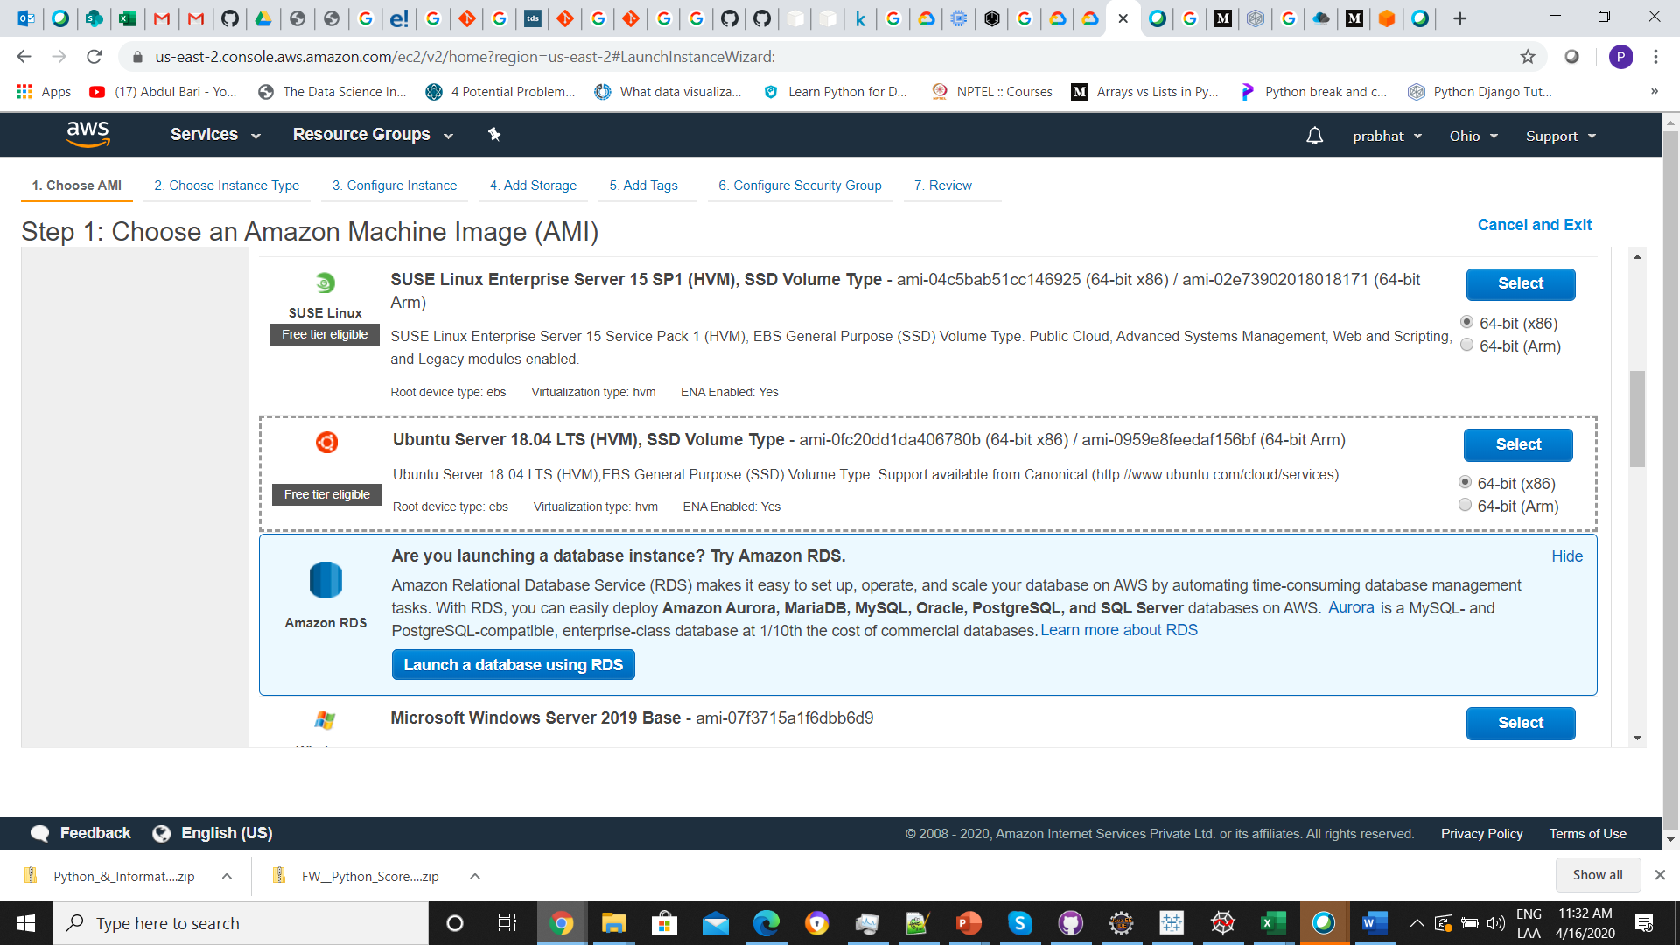

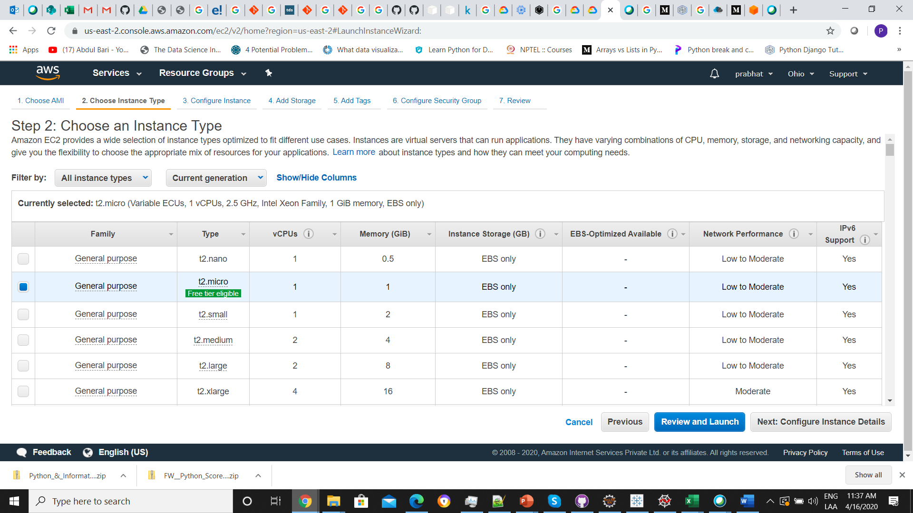

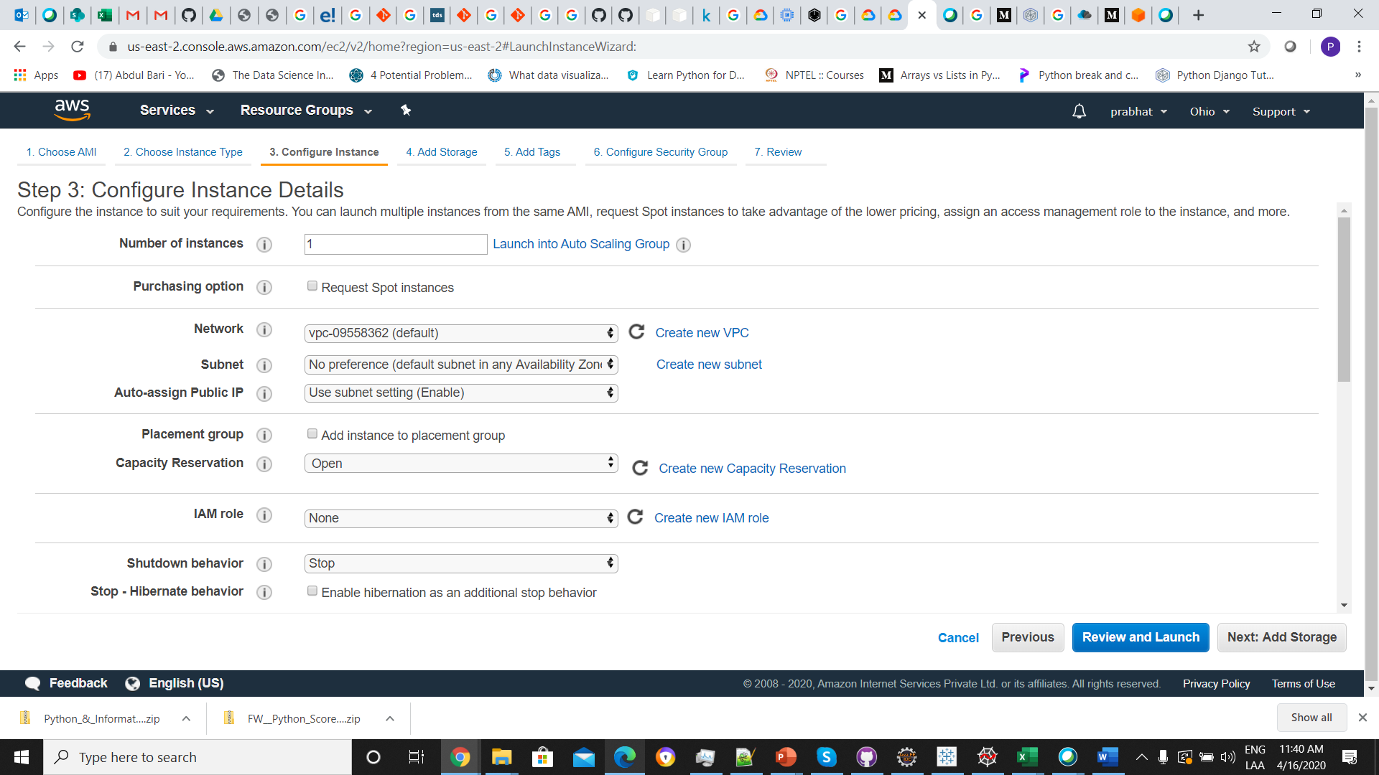

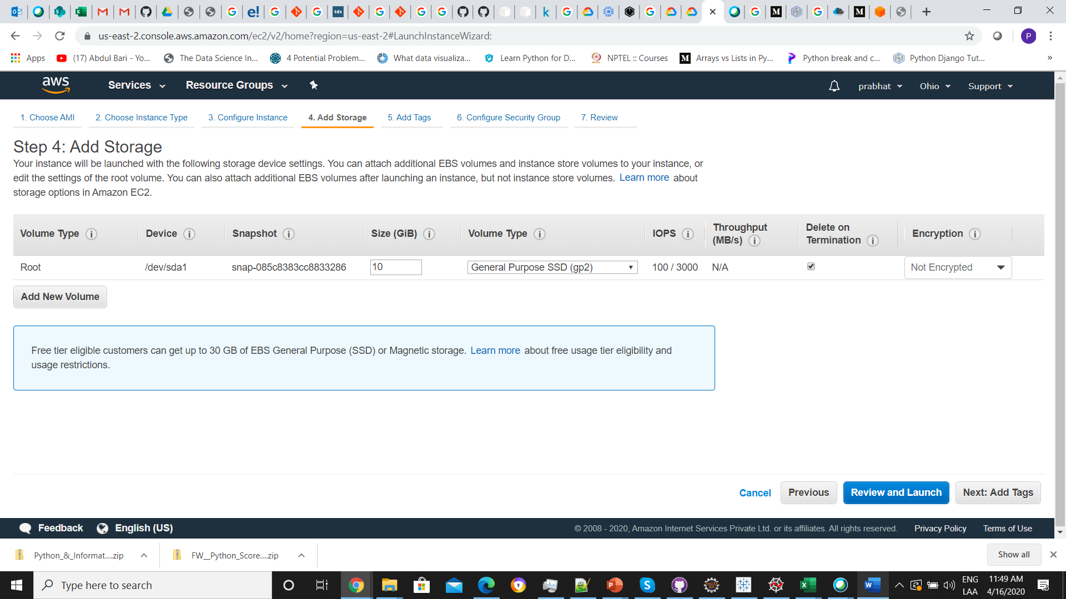

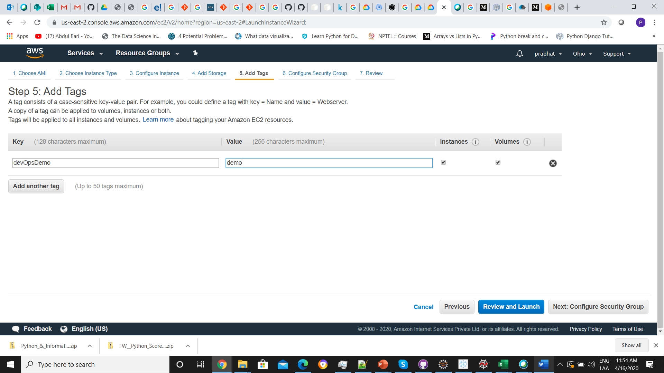

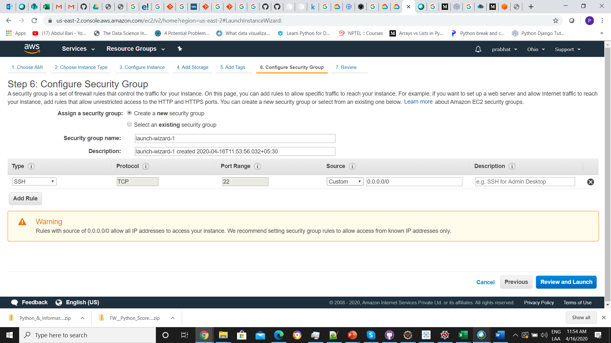

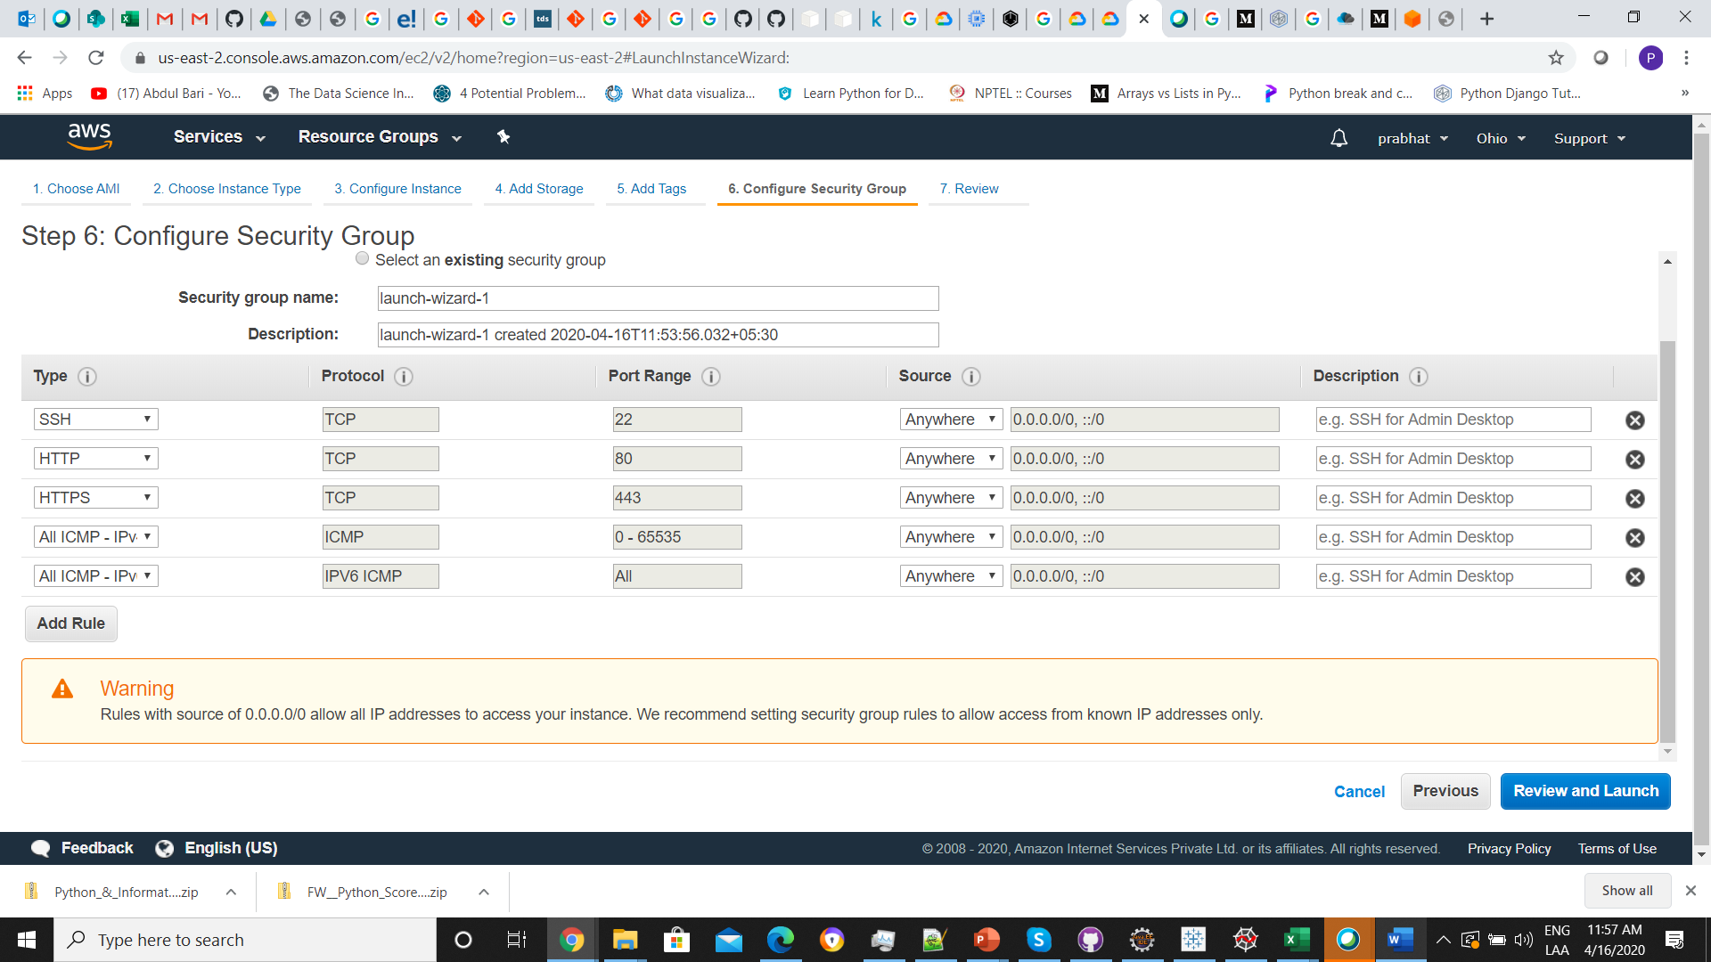

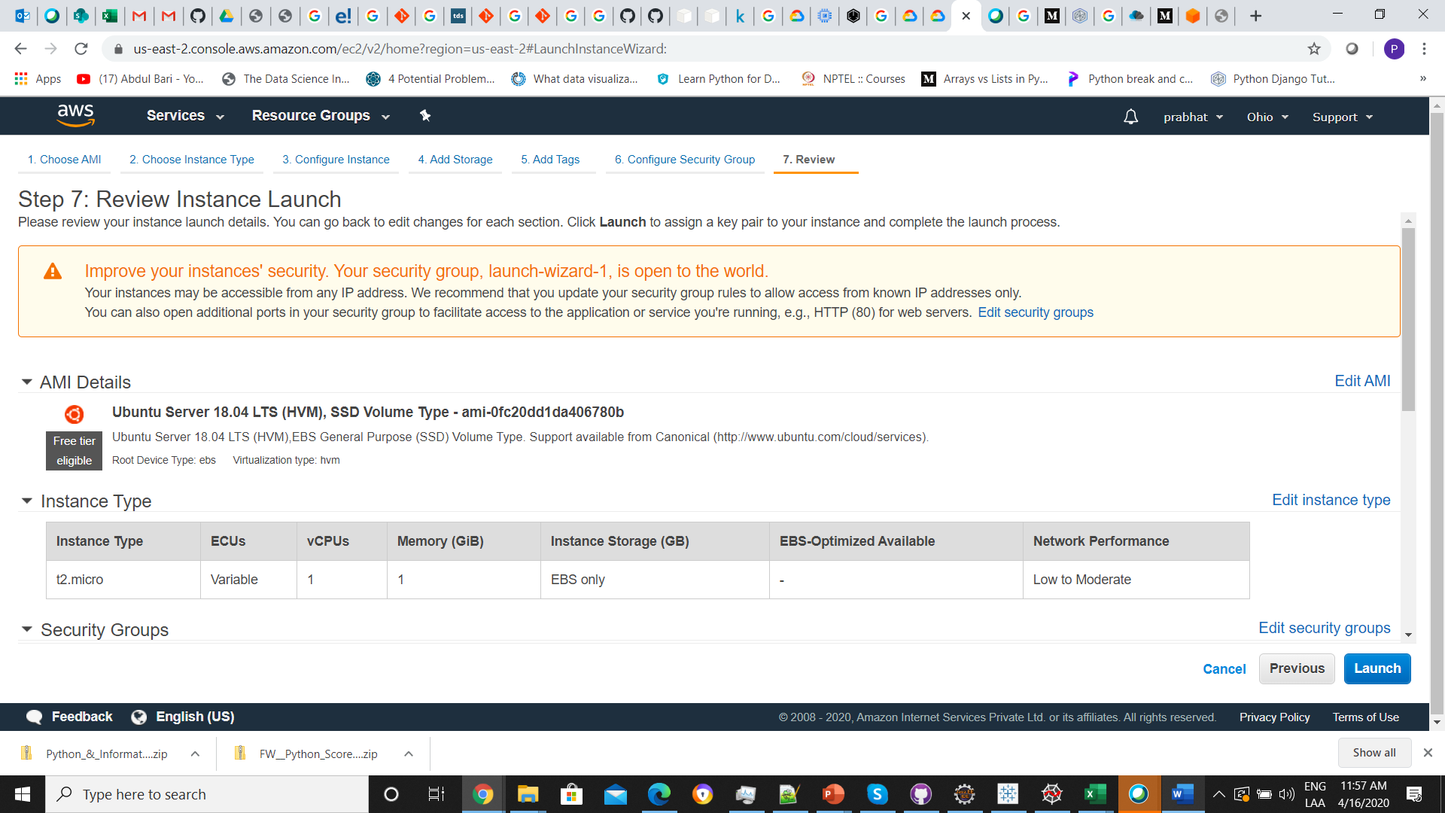

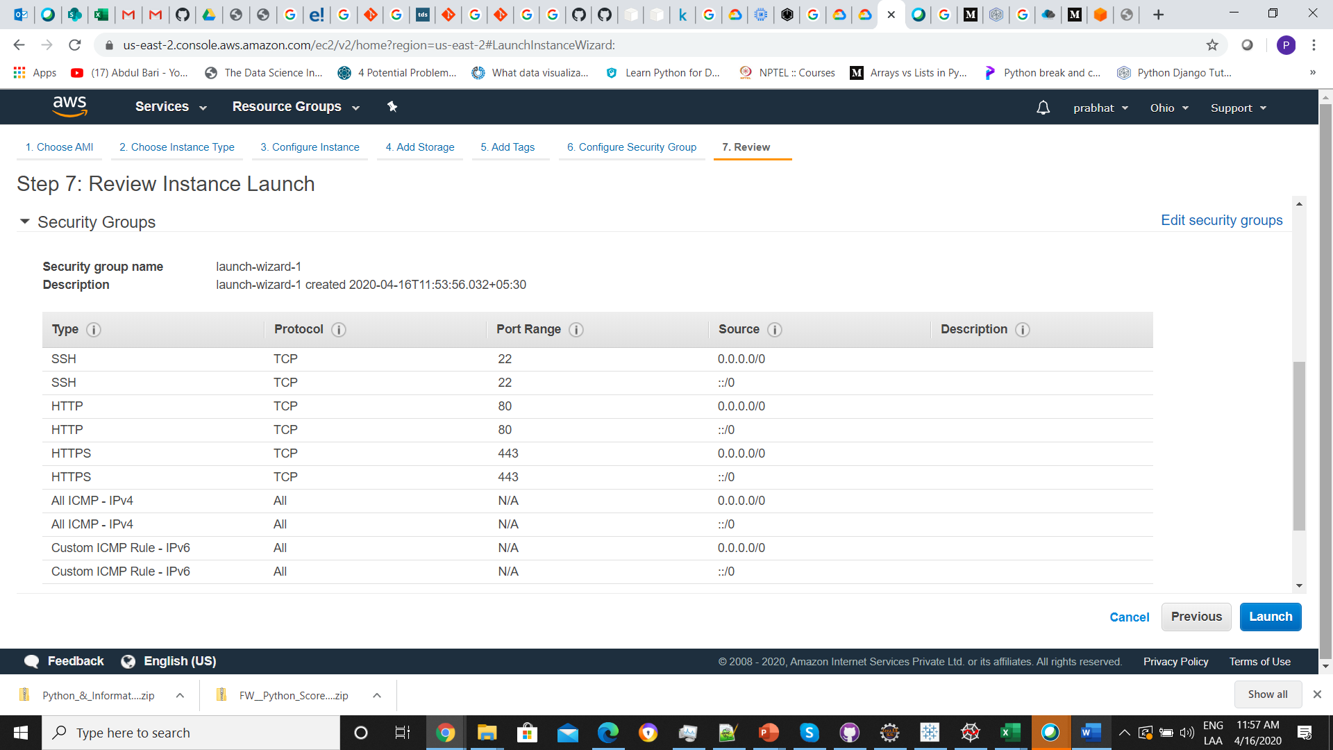

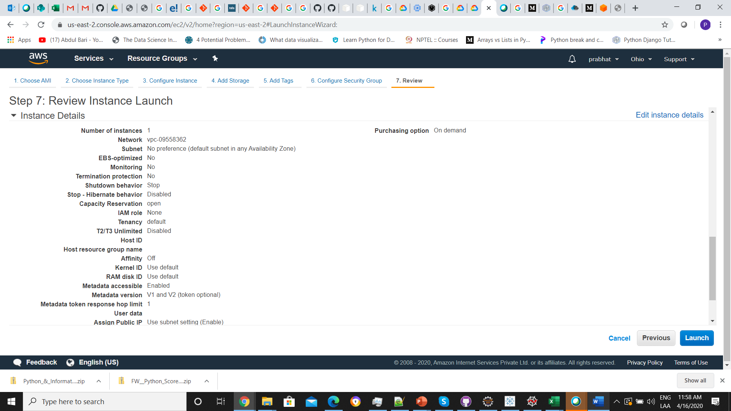

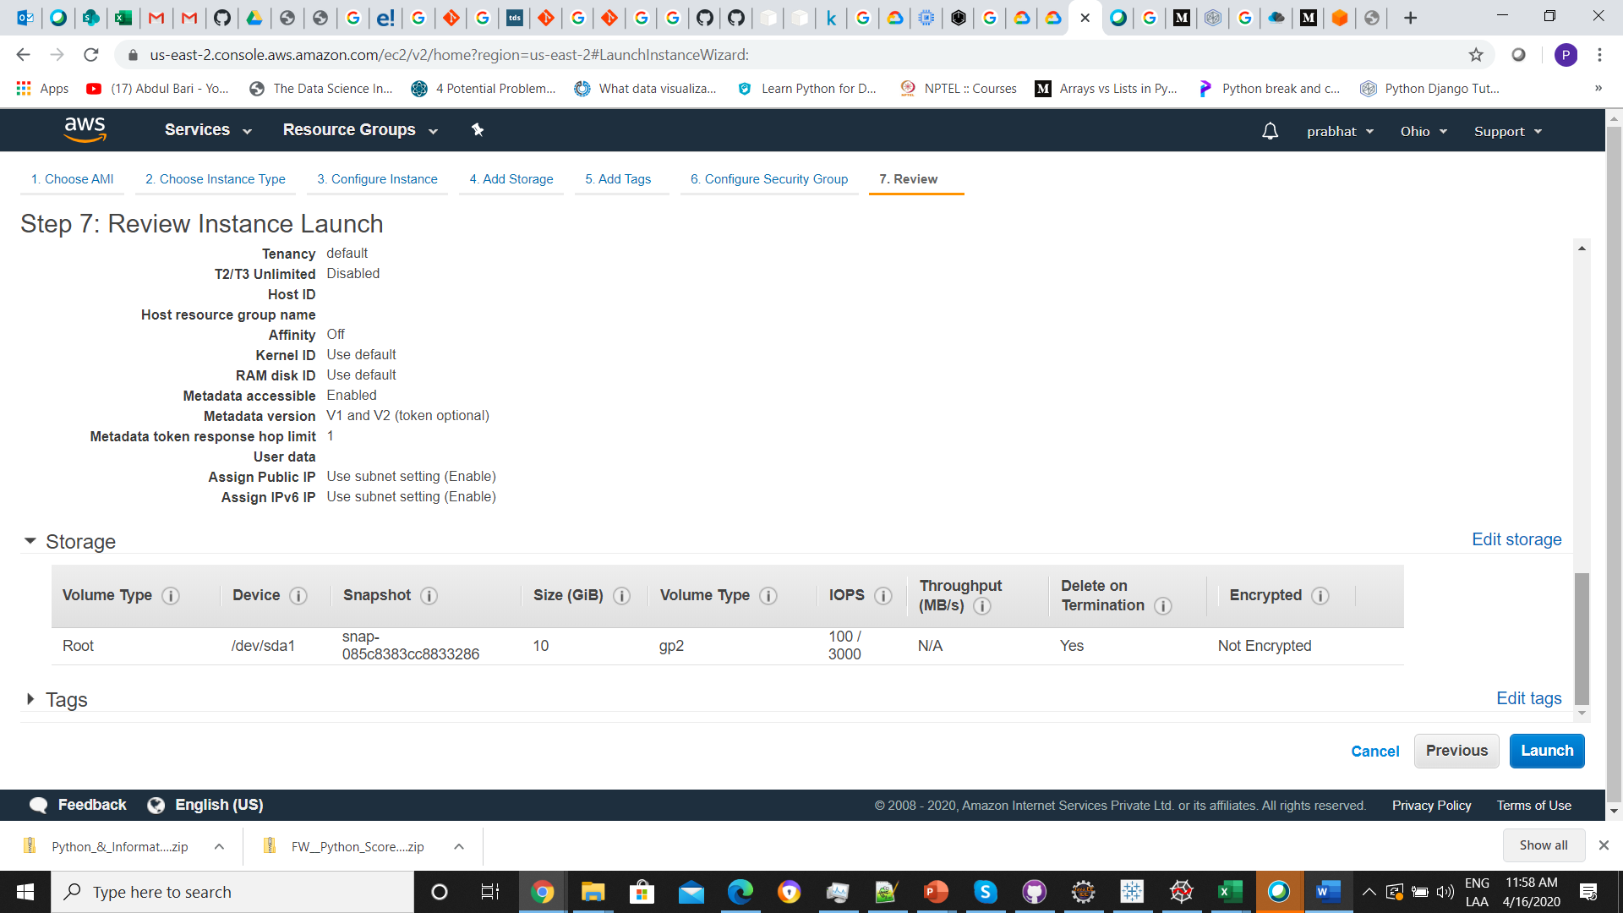

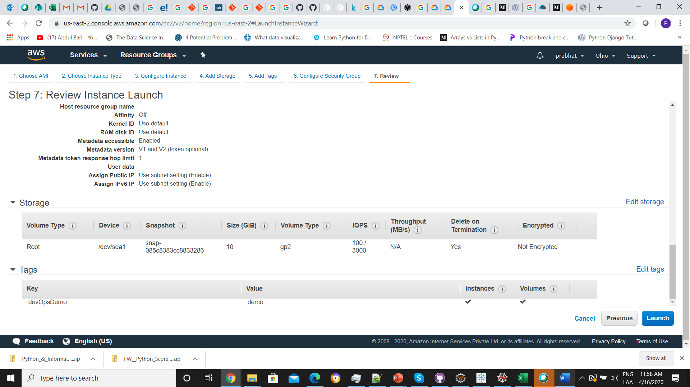

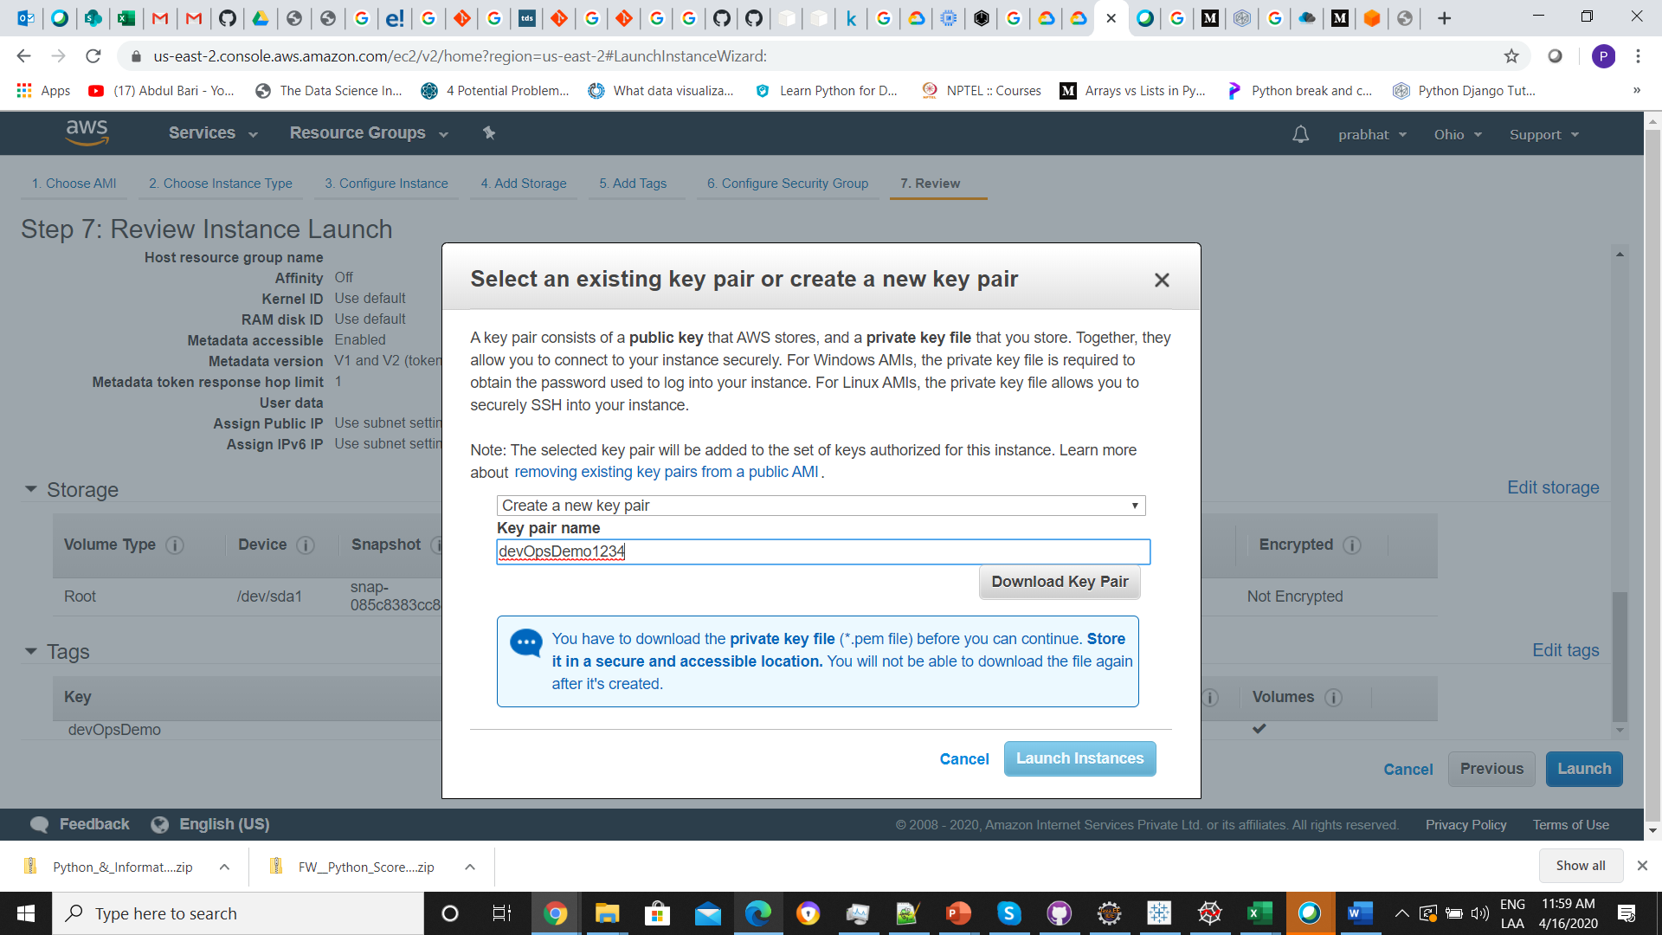

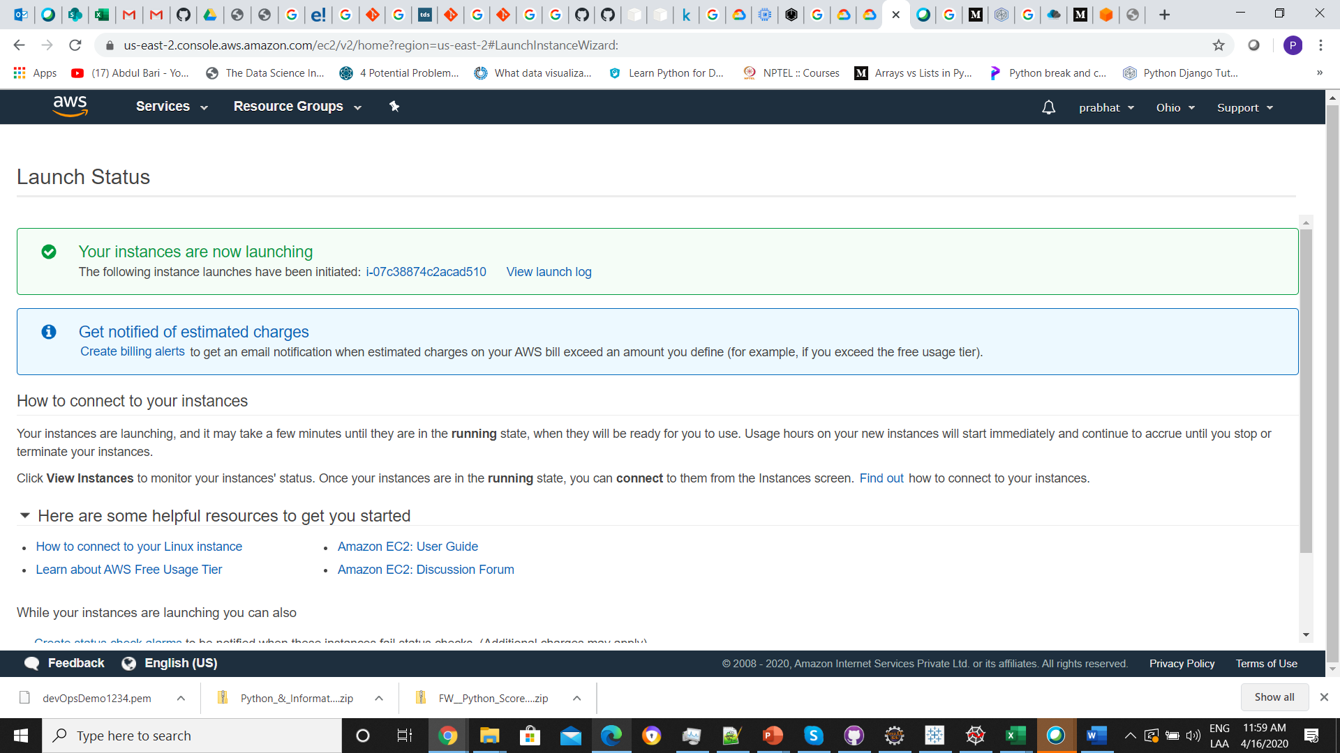

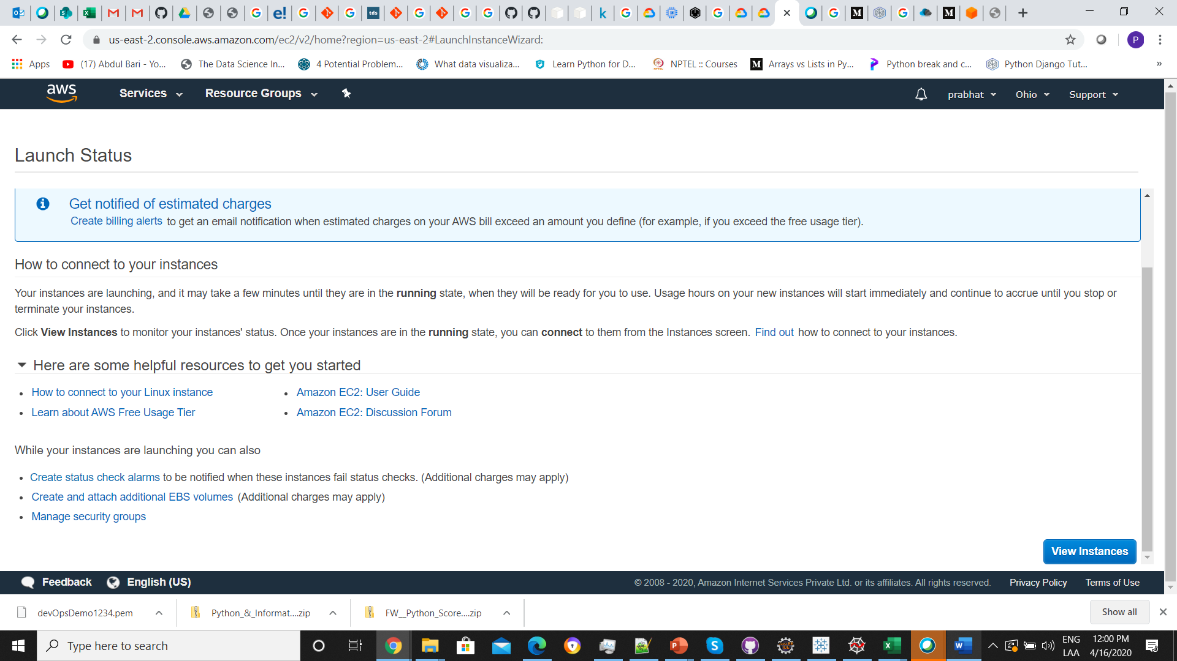

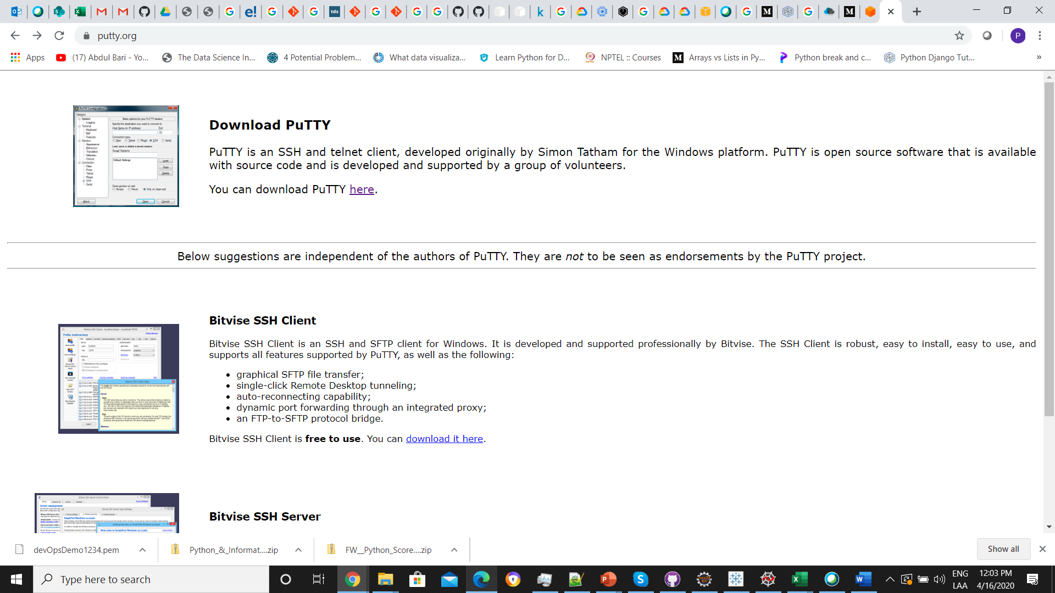

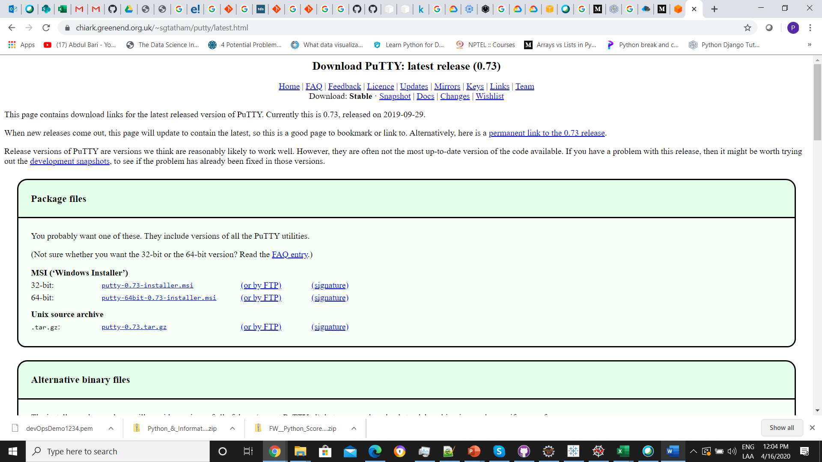

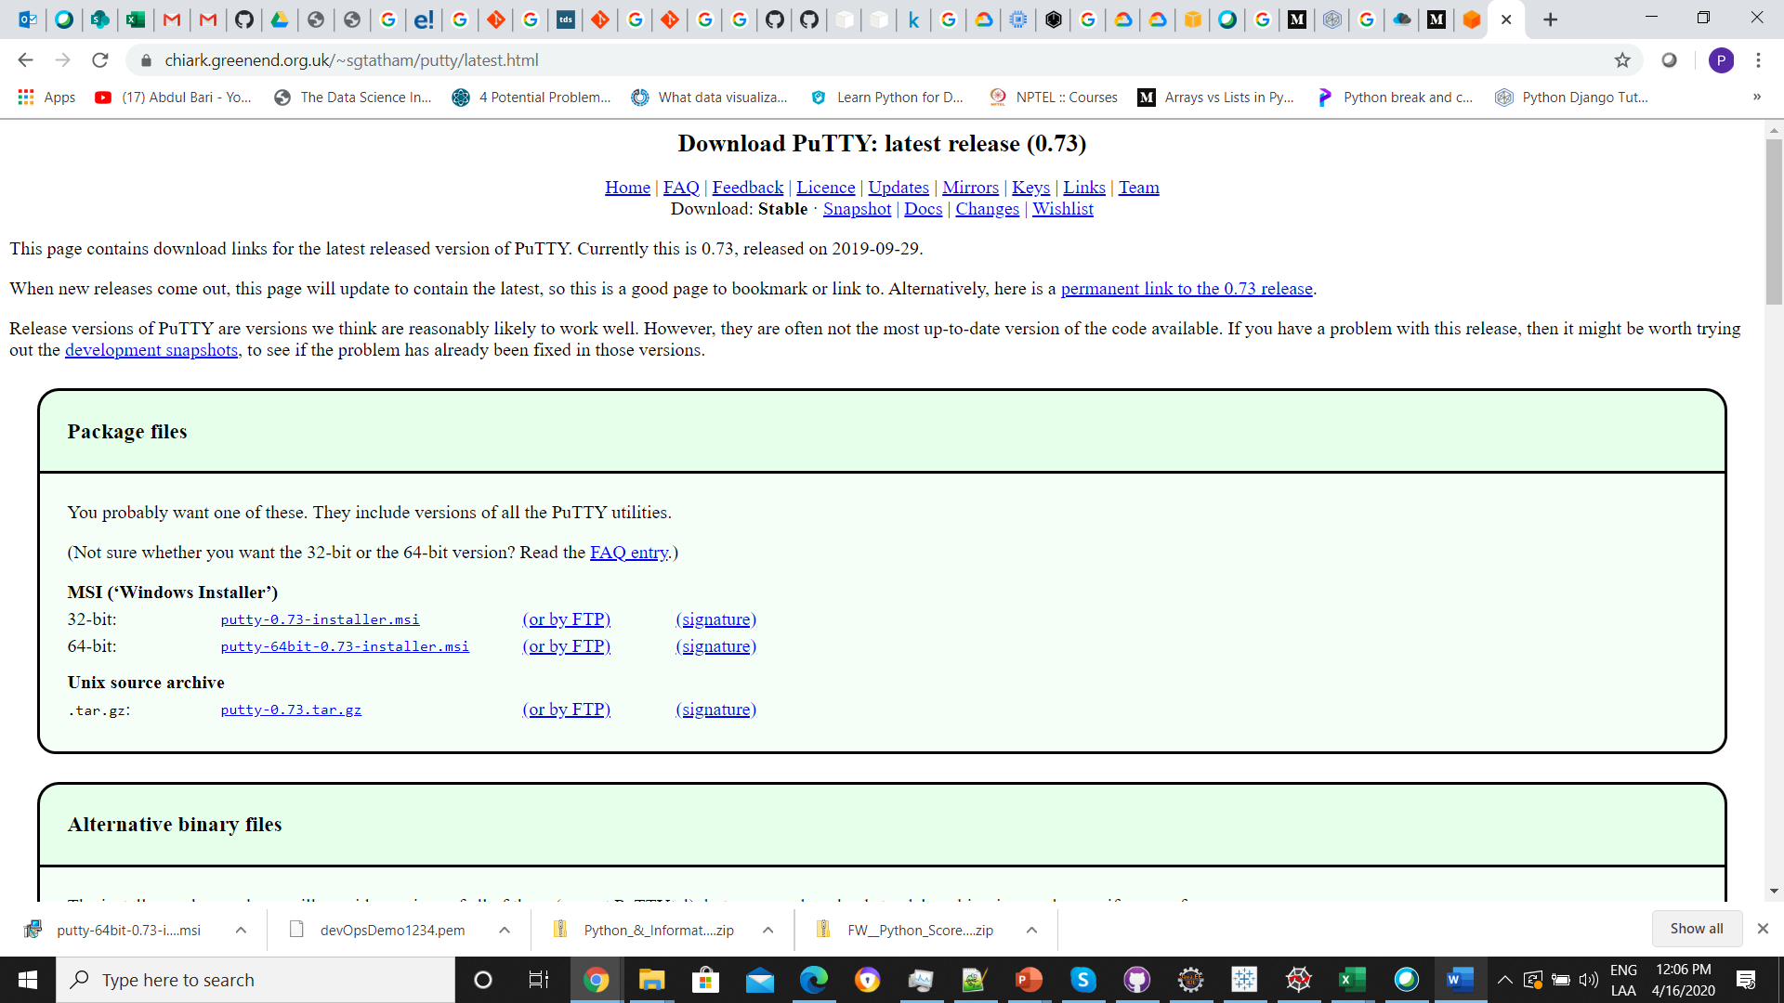

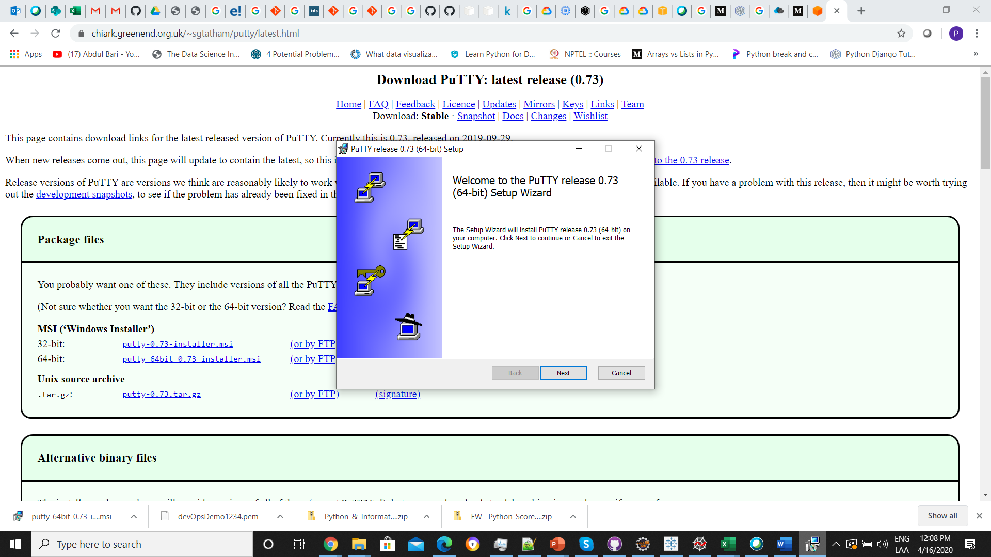

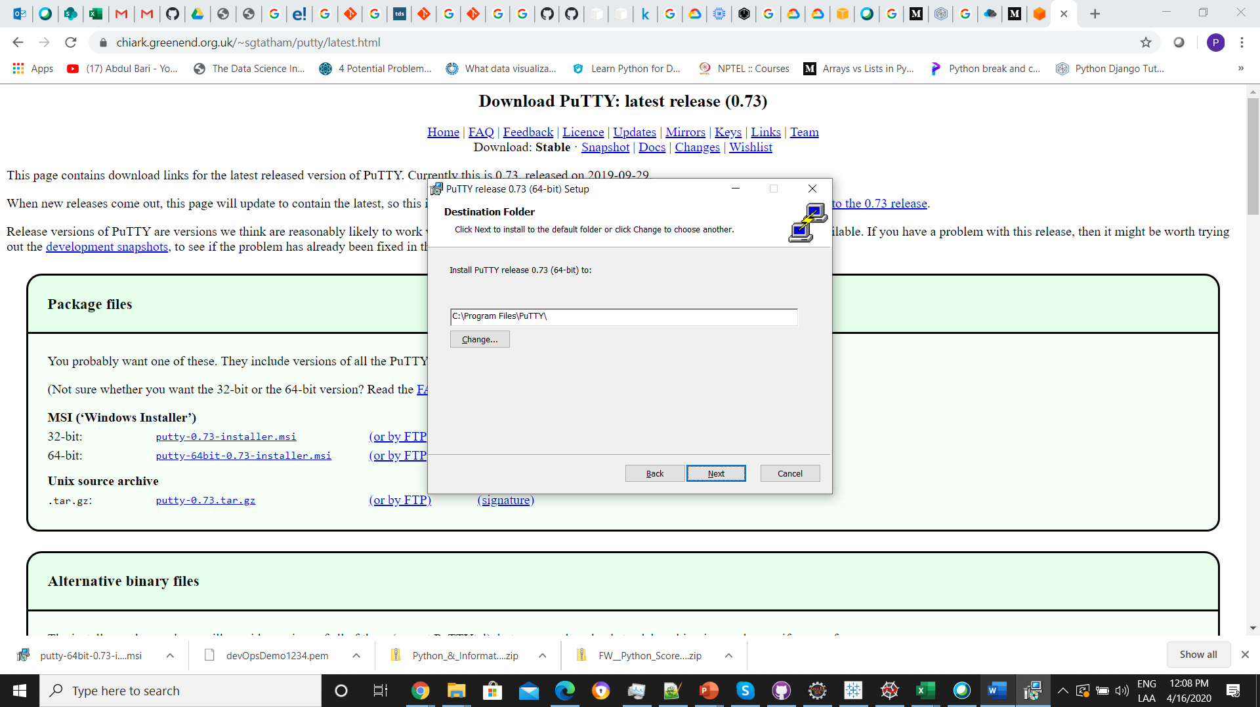

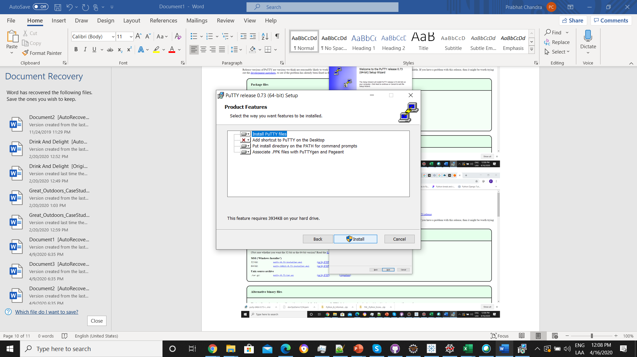

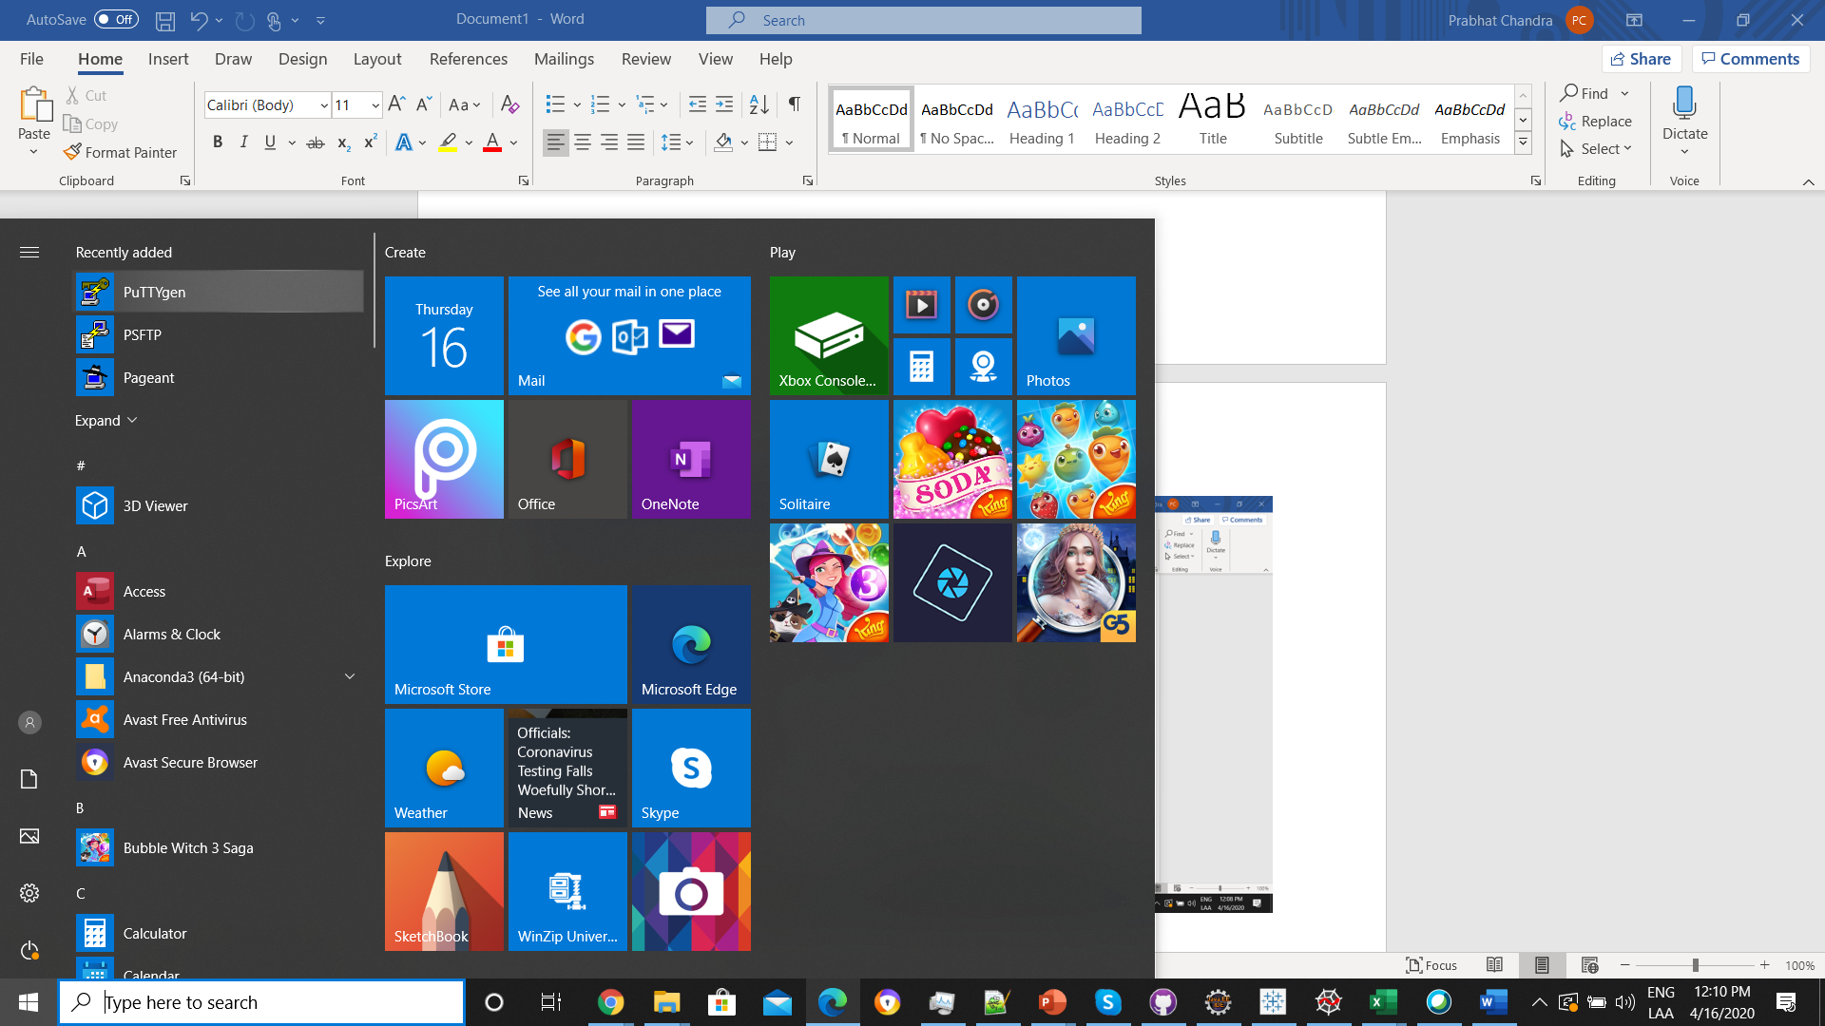

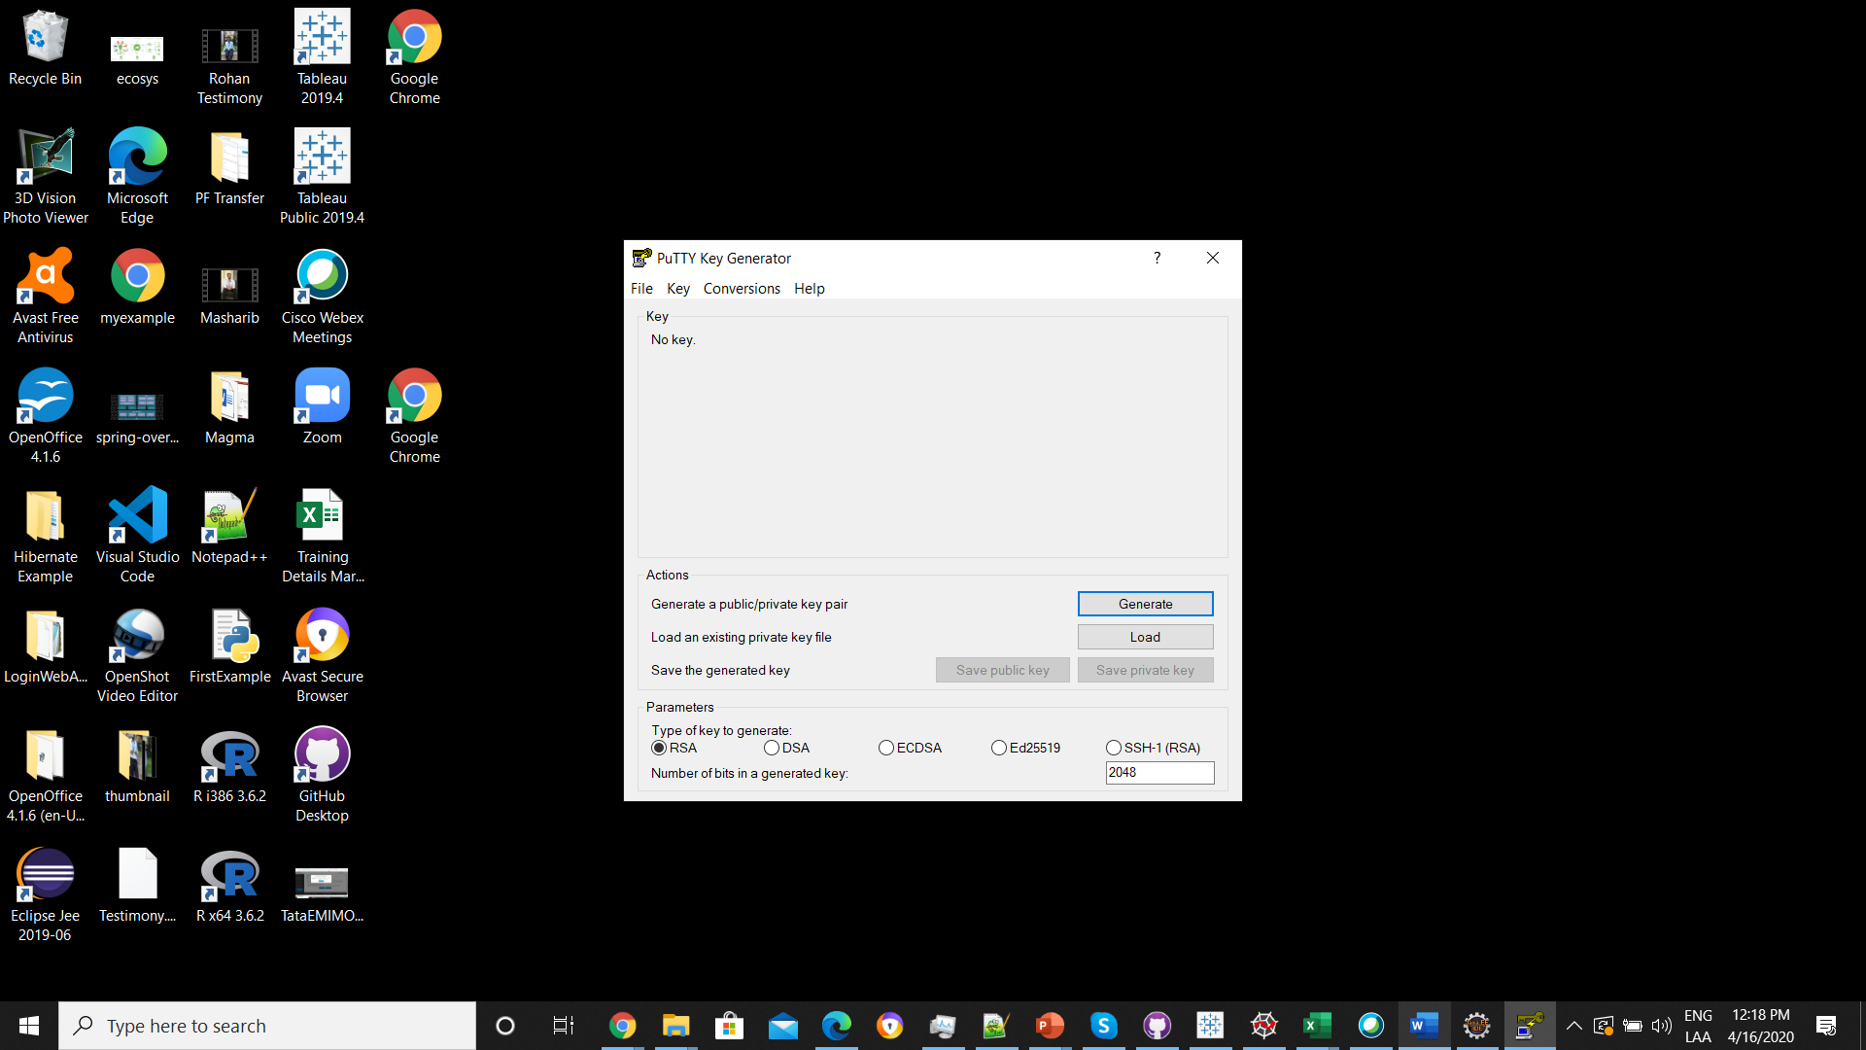

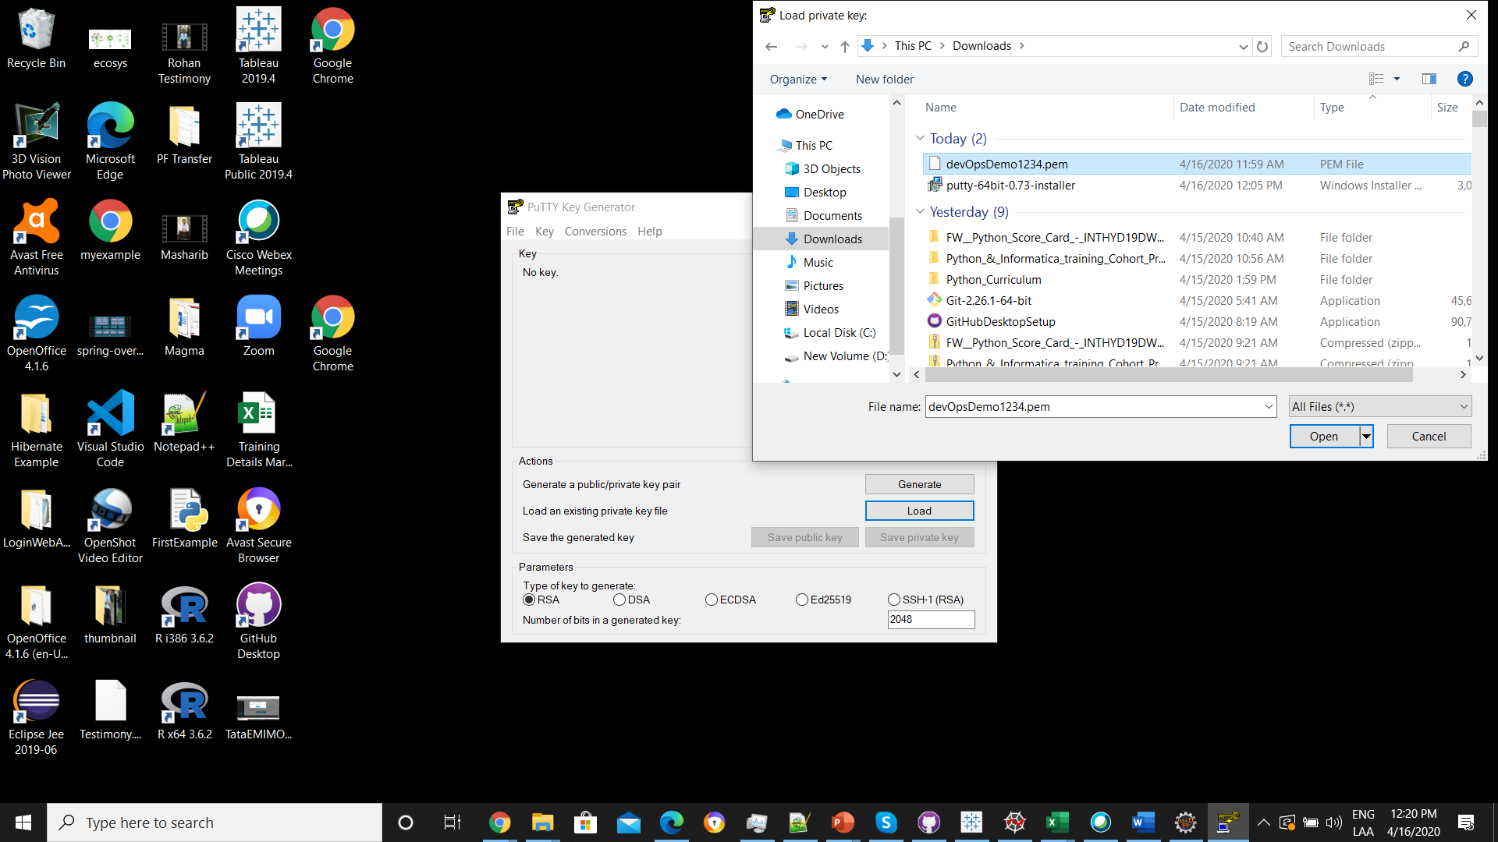

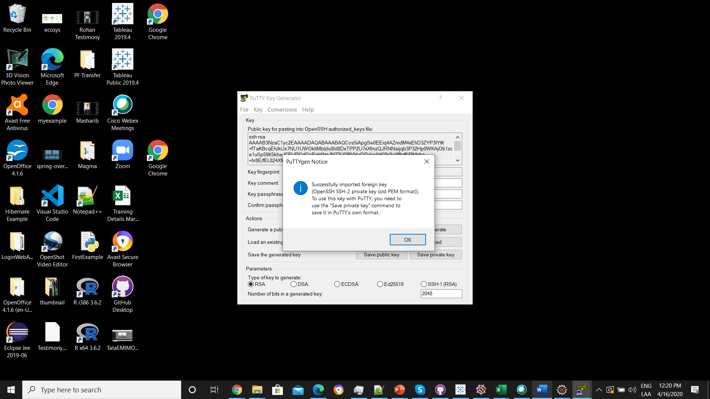

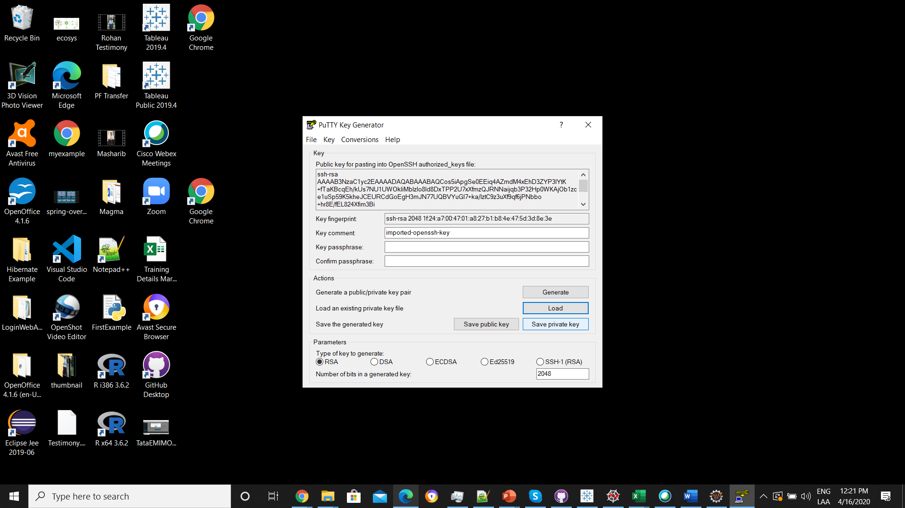

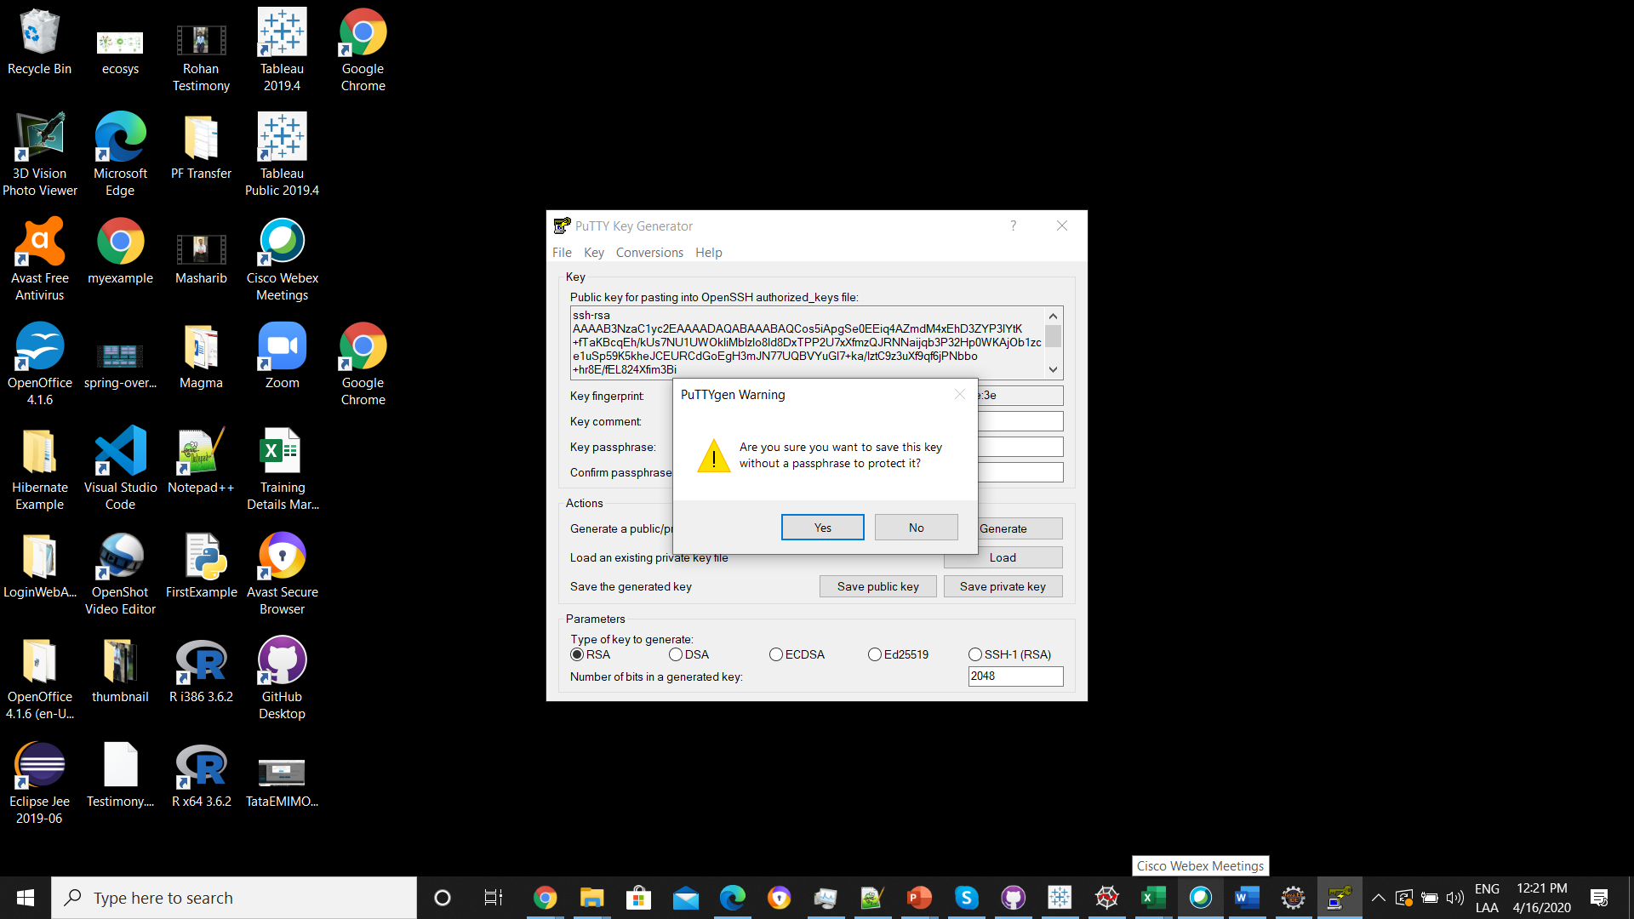

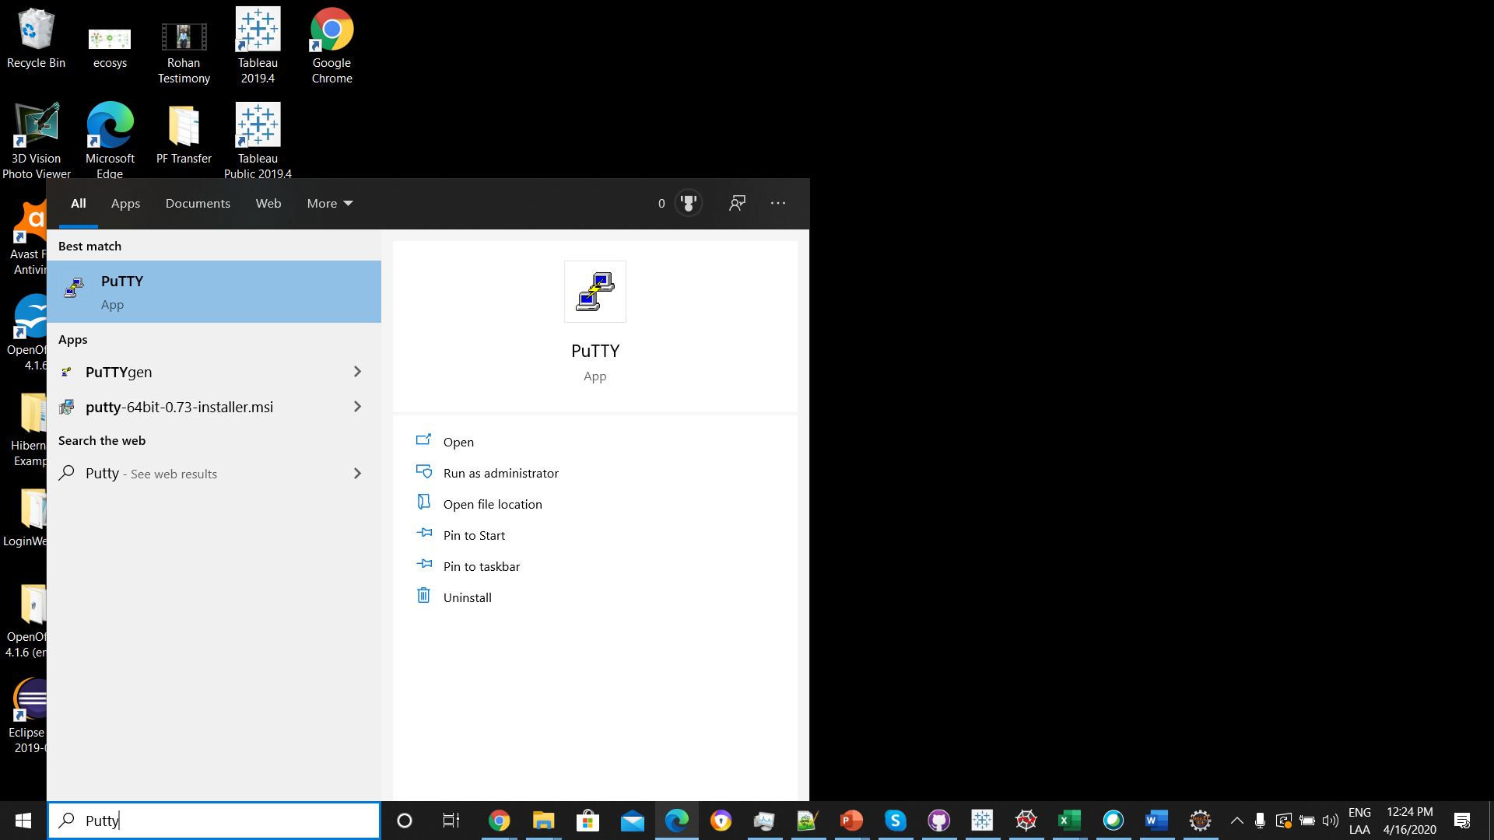

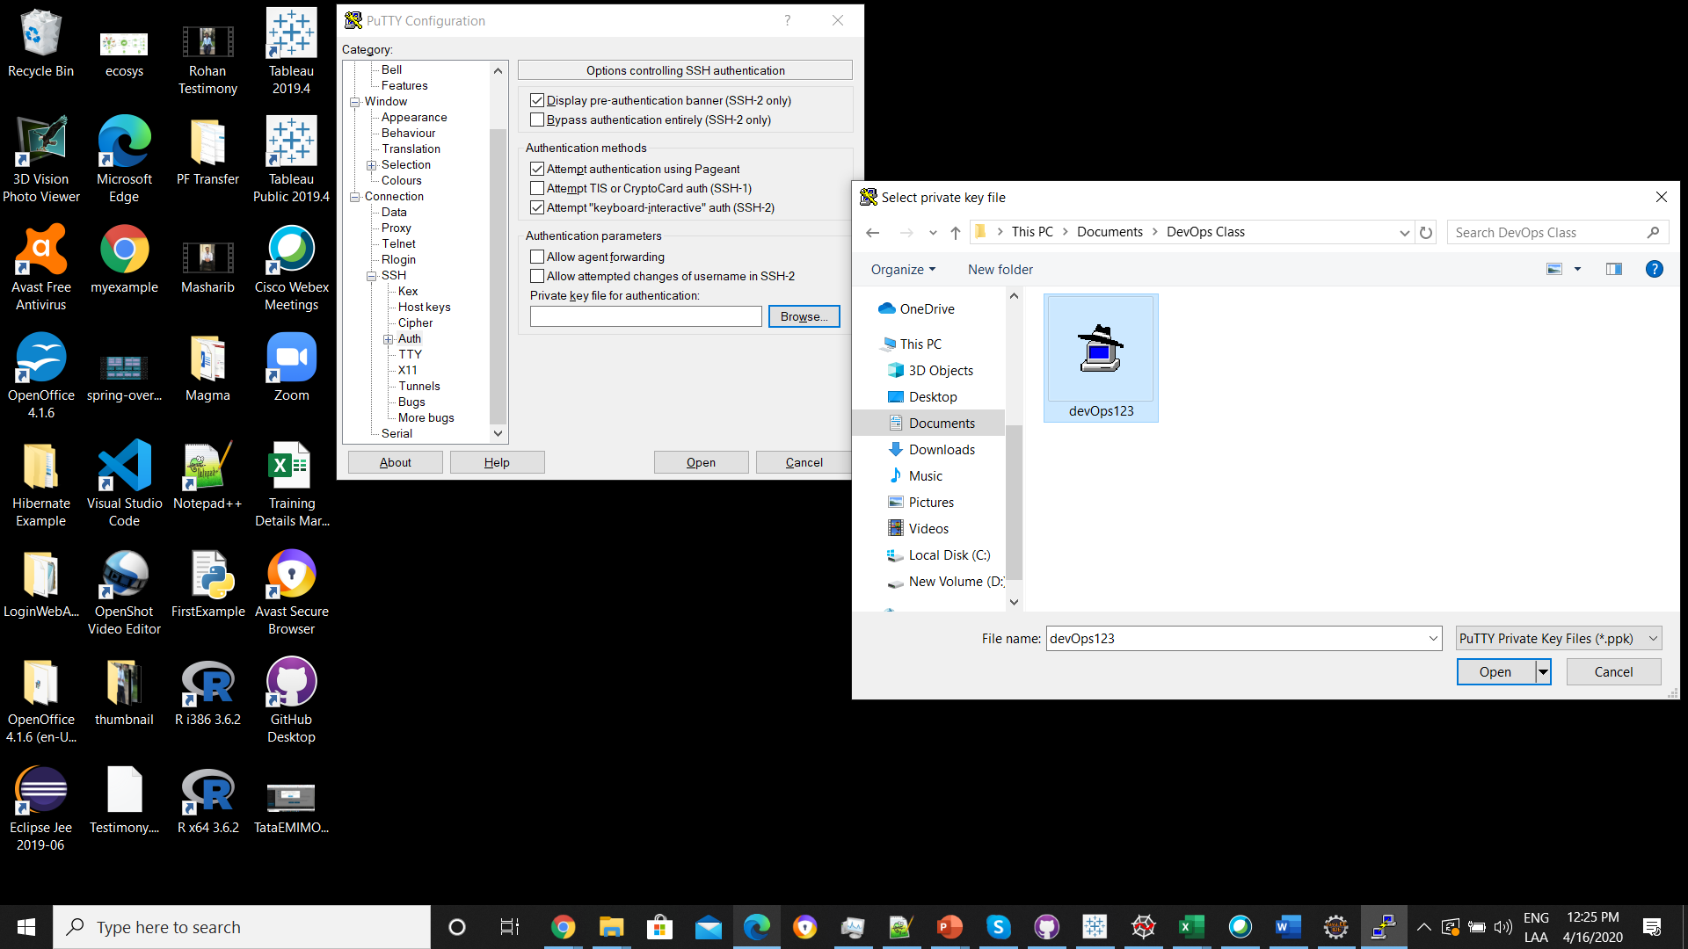

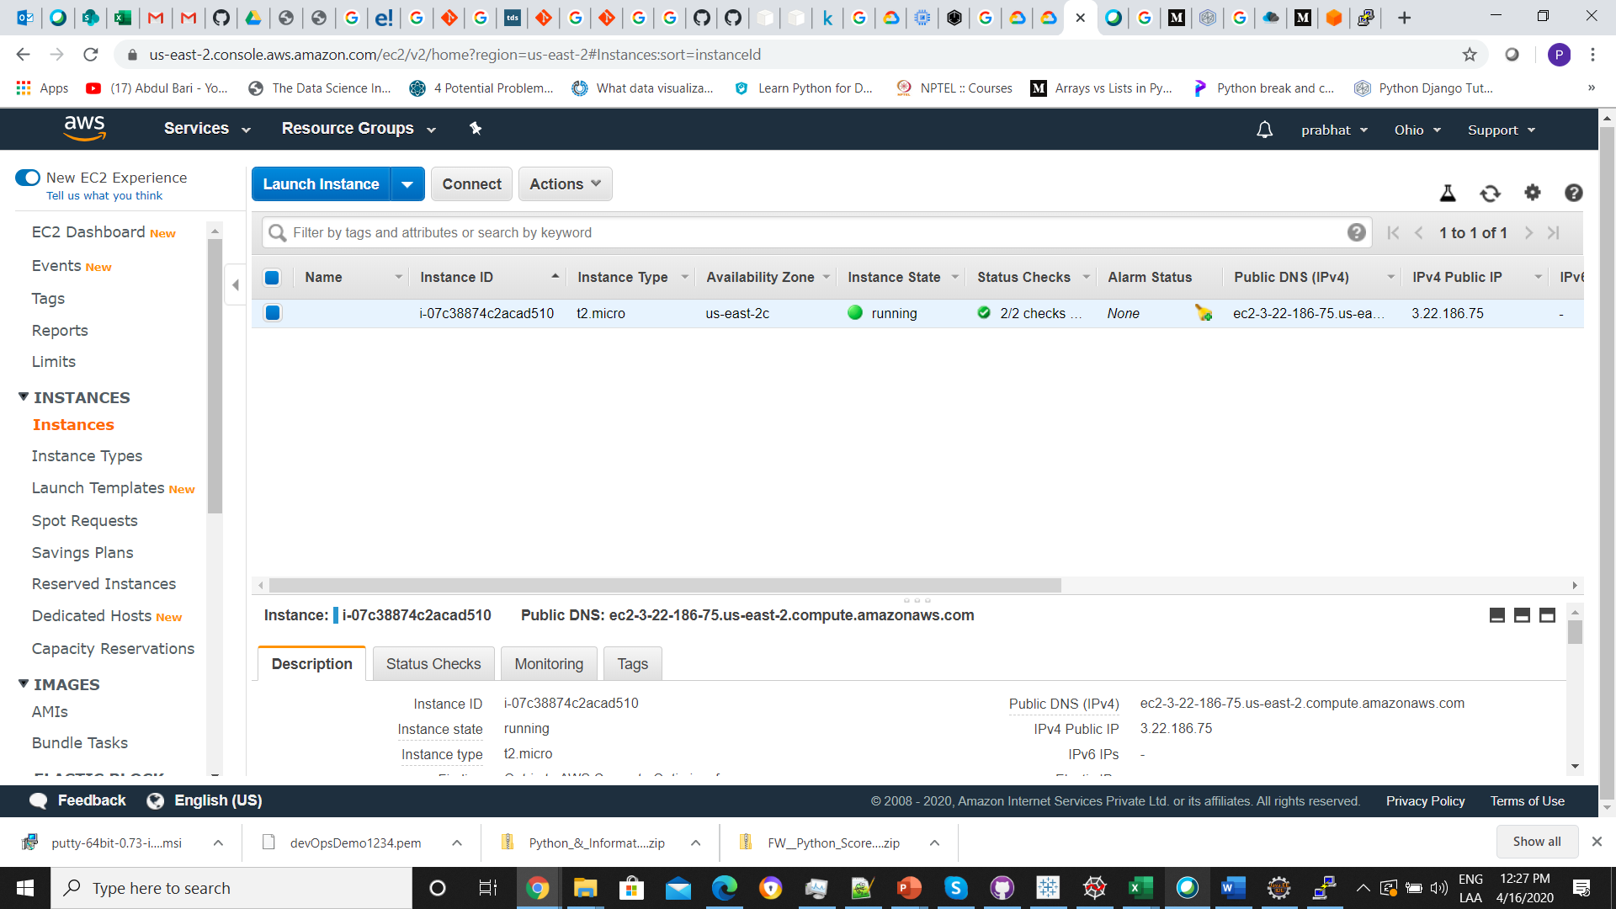

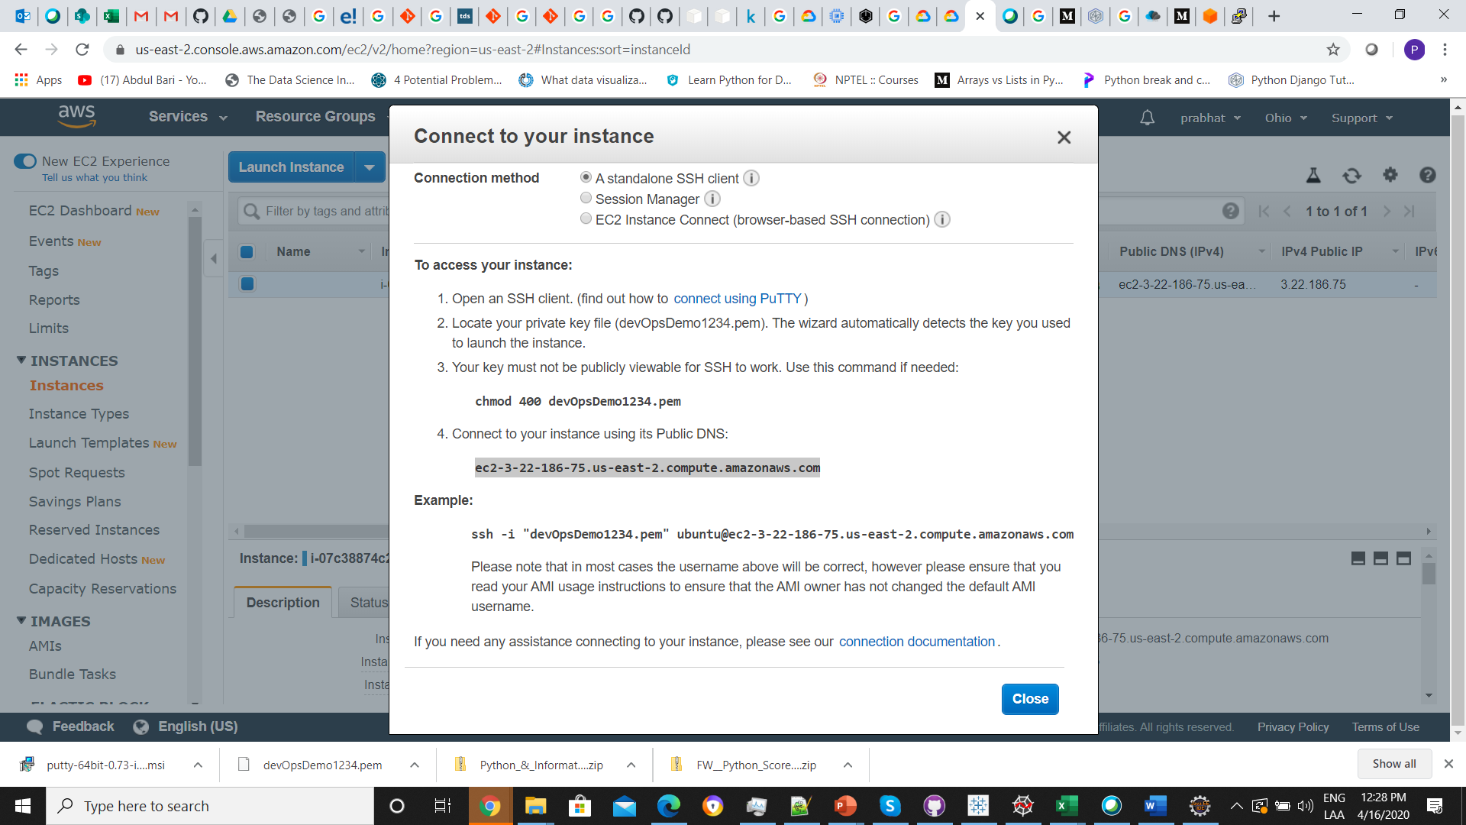

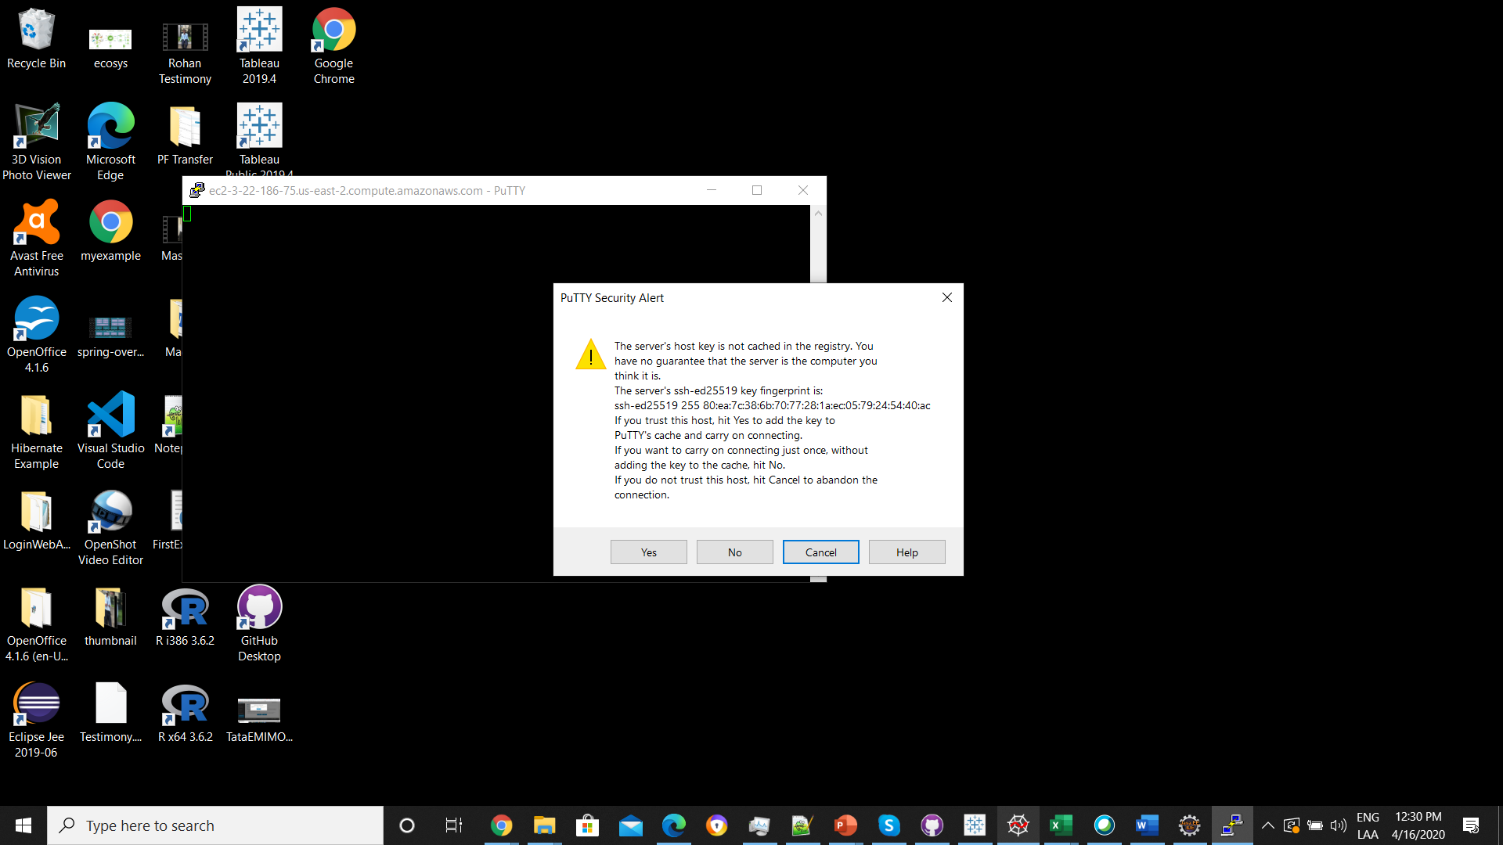

1. Installing Git on ubuntu

sudo apt-get install git

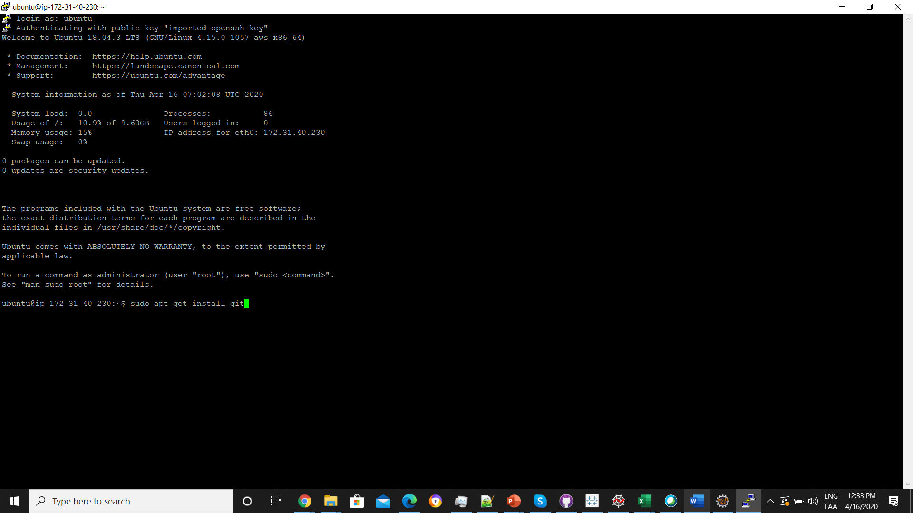

1. Configuring GitHub

Once the installation has successfully completed, the next thing to do is to set up the configuration details of the GitHub user.

To do this use the following two commands by replacing “user_name” with your GitHub username and replacing “email_id” with your email id you used to create your GitHub account.

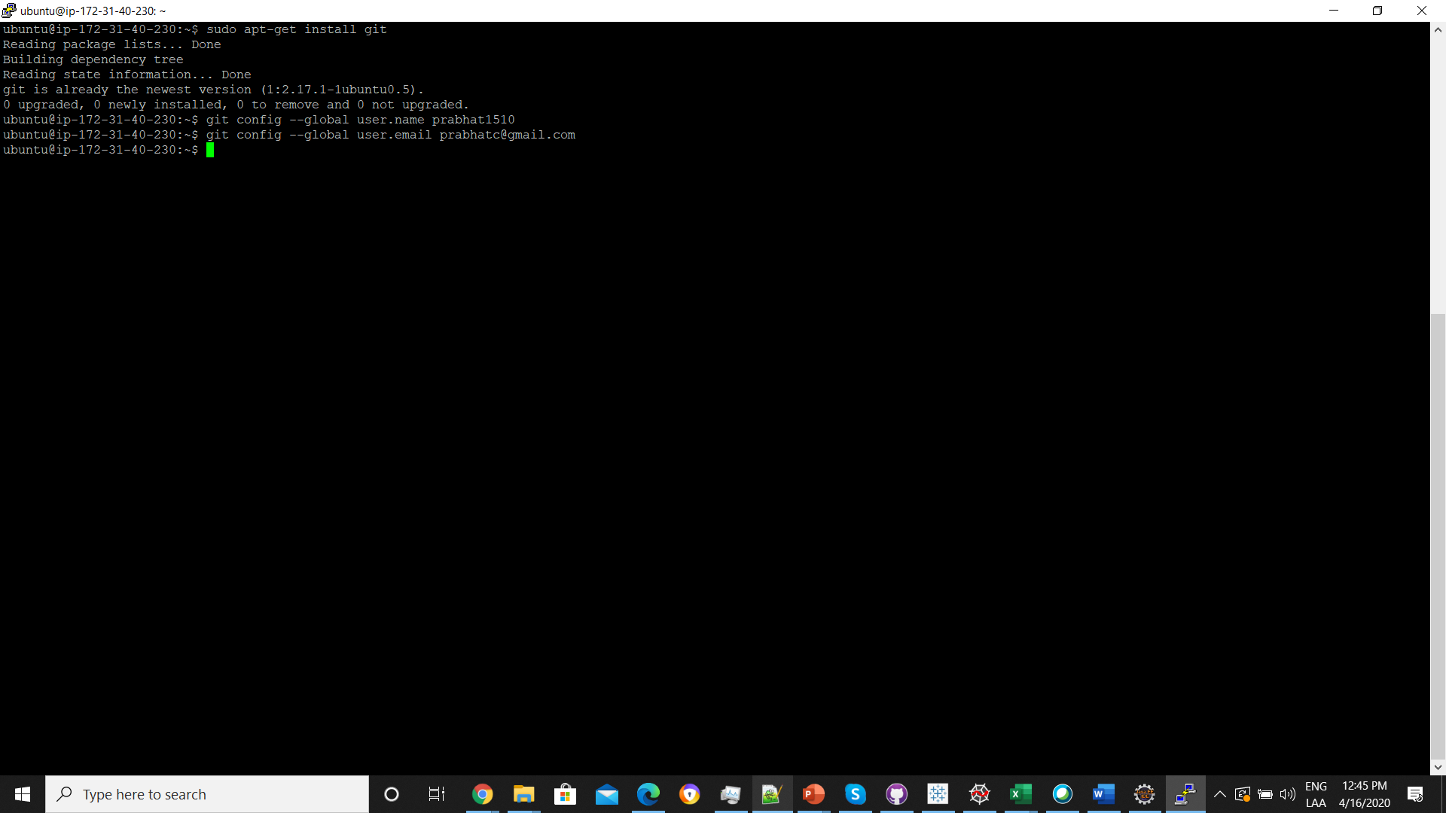

1. Creating a local repository

git init repoName

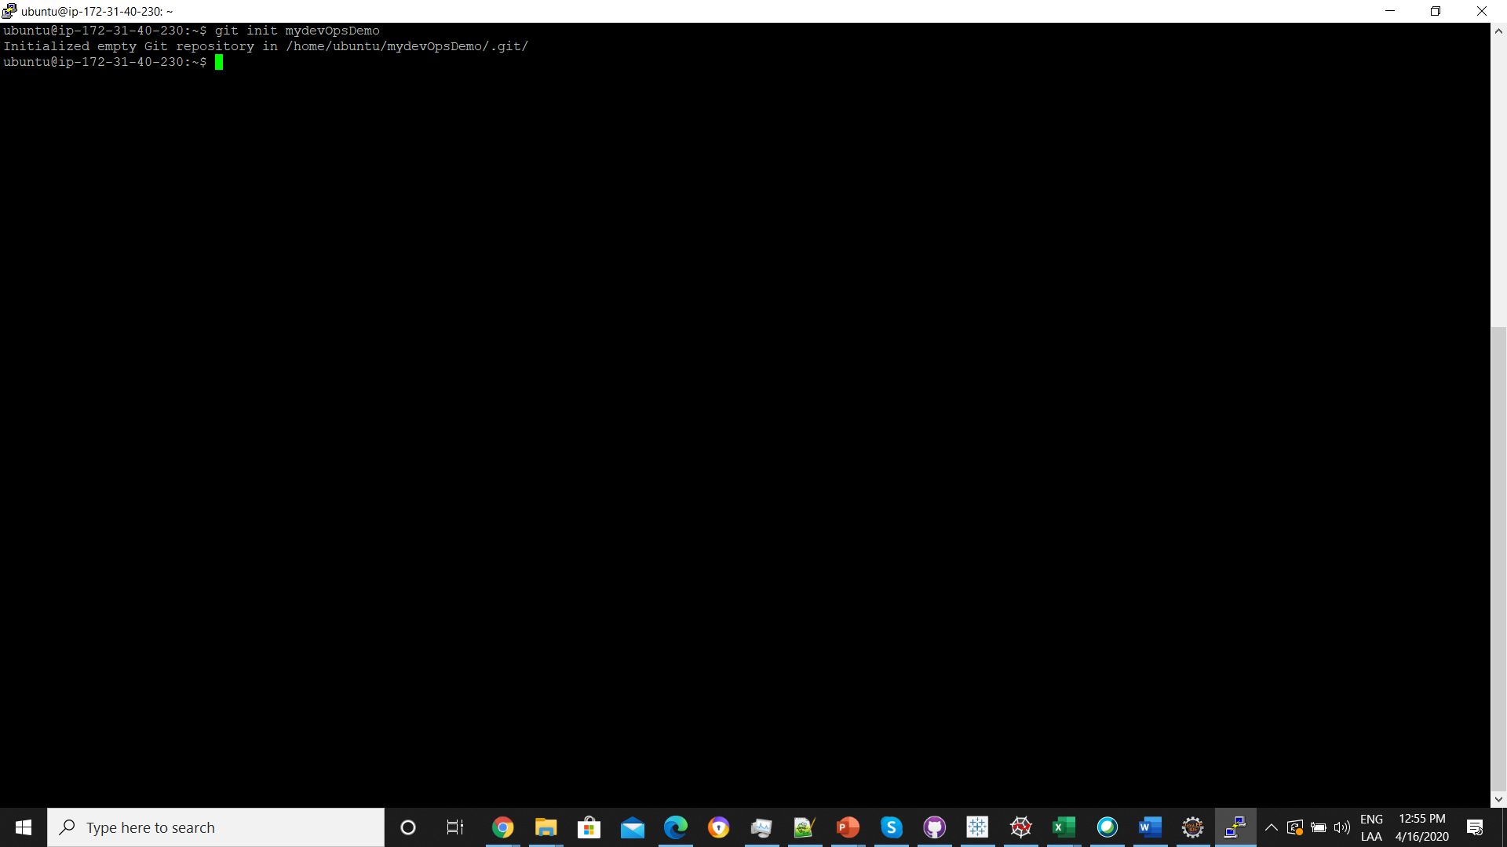

Change the directory

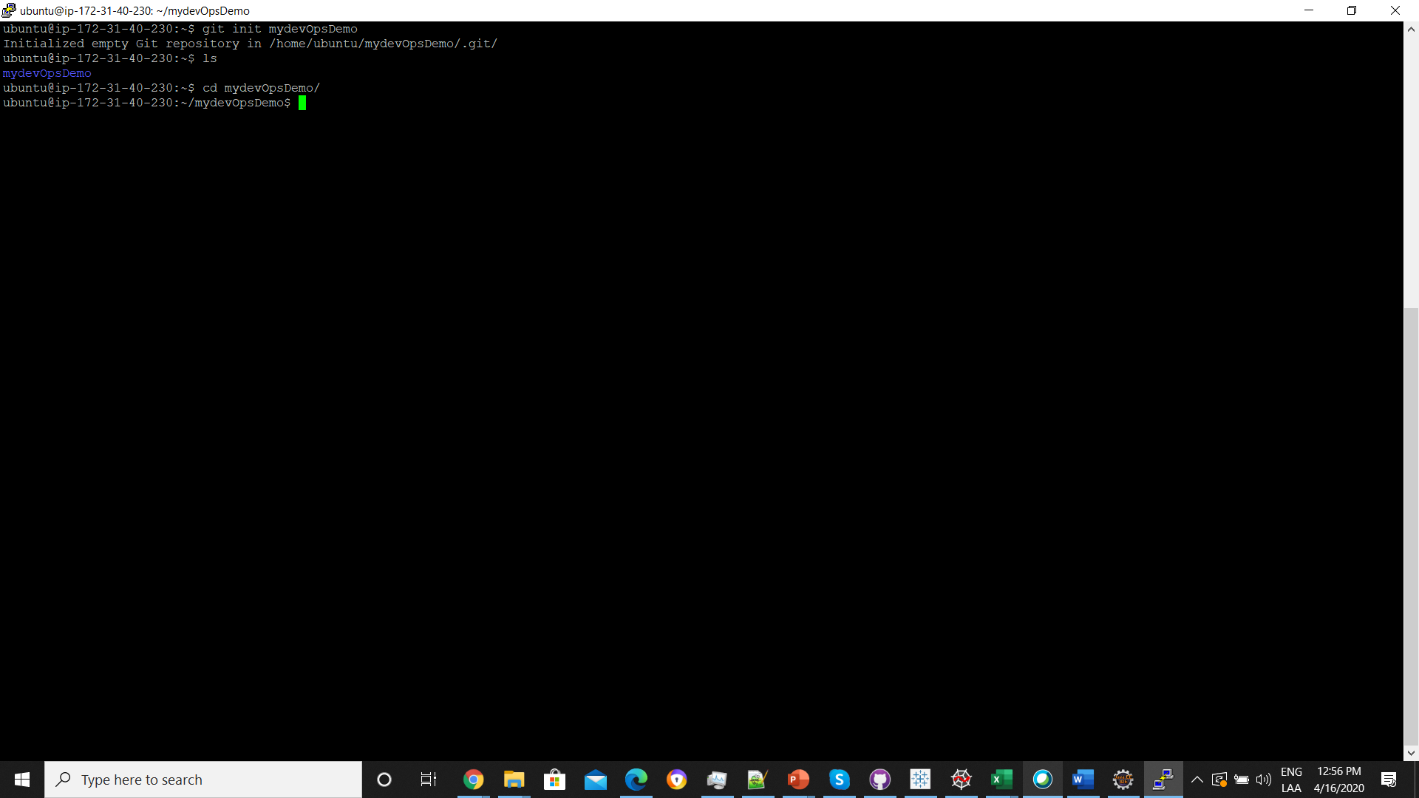

1. Creating a README file to describe the repository

You can use any other text editors. I have used gedit. If its not there install it using below commands

sudo apt install gedit

I am using vi editor

Esc :wq save and quit.

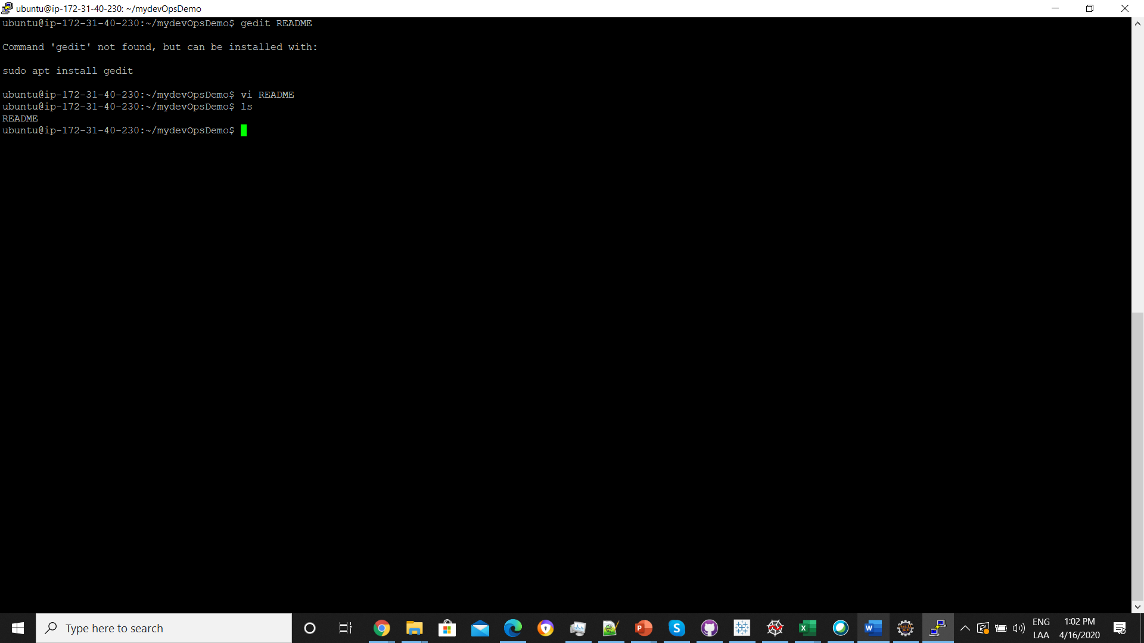

1. Adding repository files to an index

This is an important step. Here we add all the things that need to be pushed onto the website into an index.

These things might be the text files or programs that you might add for the first time into the repository or it could be adding a file that already exists but with some changes(a newer version/updated version).

Here we already have the README file. So lets create another file which contains a simple Java program and call it HelloWorld.java.

The contents of it will be :

**public** **class** HelloWorld {

/**

* **@param** args

*/

**public** **static** **void** main(String[] args) {

// **TODO** Auto-generated method stub

System.***out***.println("Hello ");

}

}

Now we have 2 files

README and HelloWorld.java

Add it to the index by using the following 2 commands:

git add README

git add HelloWorld.java

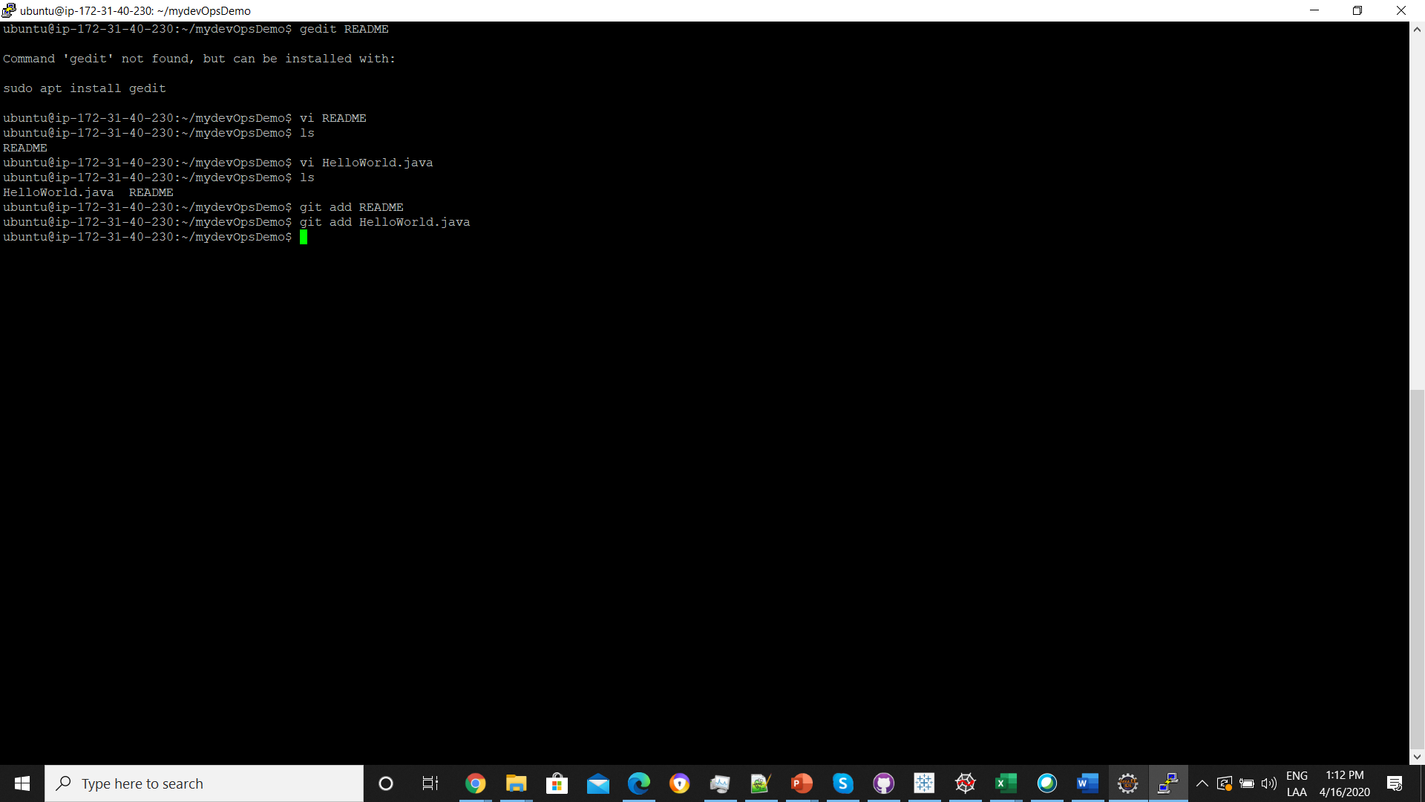

Note that the “git add” command can be used to add any number of files and folders to the index.

Here, when I say index, what I am referring to is a buffer like space that stores the files/ folders

That have to be added to the Git Repository.

1. Committing changes made to the index

Once all the files are added, we can commit it. This means that we have finalized what additions and / or changes have to be made and they are now ready to be uploaded to our repository.

Use the command:

git commit -m “comments”

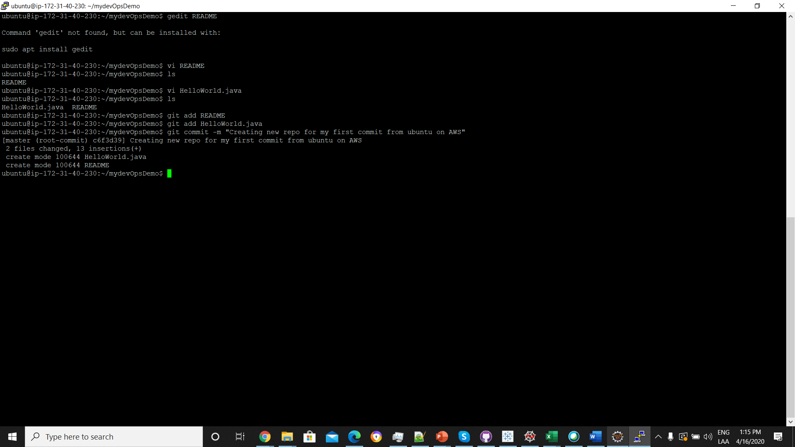

1. Creating a repository on GitHub

<https://github.com/prabhat1510/mydevOpsDemo.git>

**or create a new repository on the command line**

echo "# mydevOpsDemo" >> README.md

git init

git add README.md

git commit -m "first commit"

git remote add origin https://github.com/prabhat1510/mydevOpsDemo.git

git push -u origin master

### …or push an existing repository from the command line

git remote add origin https://github.com/prabhat1510/mydevOpsDemo.git

git push -u origin master

### …or import code from another repository

You can initialize this repository with code from a Subversion, Mercurial, or TFS project.

[**Import code**](https://github.com/prabhat1510/mydevOpsDemo/import)

git remote add origin https://github.com/prabhat1510/mydevOpsDemo.git

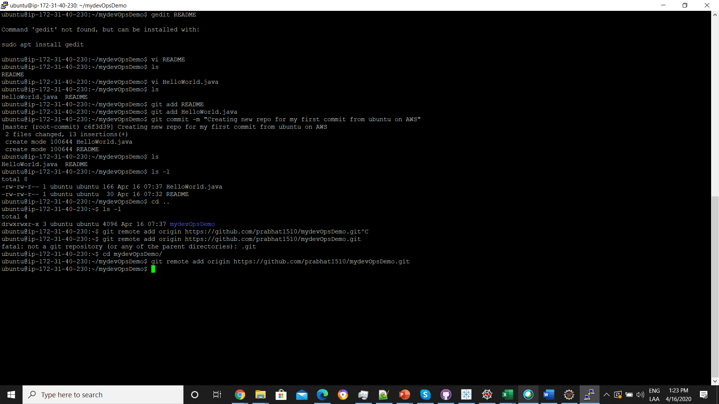

1. Pushing files in local repository to GitHub repository

git push origin master

